Document Issue: 1.1 Document Status: Final
Date Issued: April 11th, 2002 Filing Path:
                - Document Title: Simpsons 2 Core Game Design
                - Author: Joe McGinn, Shawn Lee
                - Keywords: Game Ideas, Gameplay Ideas, Feature Ideas

Revision History

Issue | Date | Person | Reason - include problem #, ECN #, etc.
0.1 | March 12, 2002 | Joe McGinn | Initial draft of document.
1.0 | March 15, 2002 | Joe McGinn | Final Preliminary Design (delivered to Fox March 15 2002)
1.1 | April 11, 2002 | Joe McGinn | Core Design (delivered to Fox April 15 2002)

Table of Contents
1 Core Game Design 8
2 High Concept 9
2.1 Game Concept 9
2.2 Game Goals 9
2.3 Target Audience 9
2.4 Game Story 9
2.5 Game Modes 9
2.6 Major Gameplay Features 10
2.7 Game Worlds 11
2.8 Gameplay Example Error! Bookmark not defined.
3 Story Mode 12
4 Story 13
4.1 Product Goals 13
4.2 Story Goals 13
4.3 Content 13
5 Characters and Vehicles 14
5.1 Walkers – User Controlled Out of the Car 14
5.2 Drivers and Their Vehicles 14
5.3 Passengers and Pedestrians 14
6 Vehicle Chase AI 16
6.1 Goals 16
6.2 Prioritized Features 16
6.3 Tools 19
6.4 Content 19
7 Vehicle Escape AI 21
7.1 Goals 21
7.2 Prioritized Features 21
7.3 Tools 22
7.4 Content 22
8 Collectibles 23
8.1 Goals 23
8.2 Features – In Car 23
8.3 Features – On Foot 23
8.4 Design Notes 24
8.5 Questions 24
8.6 Tools 24
8.7 Content 25
9 Gameplay Controls 26
9.1 Goals 26
9.2 Features 26
9.3 Tools 26
10 Switching Vehicles In Game 28
10.1 Goals 28
10.2 Features 28
10.3 Tools 28
11 Mission Scripter 29
11.1 Mission Flow 29
11.2 Objectives 31
11.3 Sunday Drive Objectives 31
11.3.1 Example One – Get in to a Car 31
11.3.2 Example Two – Talk to Two People 31
11.3.3 Example Three – Get into a Can and Drive to Start Location 32
11.4 Gameplay Objectives 32
11.4.1 Failure Conditions 33
11.4.2 Other Attributes 33
11.4.3 Gameplay Example Objectives 34
11.5 Real-time AI Scripting 34
12 Mission Design 35
12.1 Goals 35
12.2 Level Order 35
12.3 Level 1 - Evergreen Terrace 35
12.3.1 Training – Missions 1 through 5 35
12.3.2 Mission 1 (L1M1) – Drive the Car 37
12.3.3 Mission 2 (L1M2) – Chase AI, Vehicle Damage 37
12.3.4 Mission 3 (L1M3) – Pick up Passengers 38
12.3.5 Mission 4 (L1M4) – High Speed Starts 38
12.3.6 Mission 5 (L1M5) – Vehicle Countermeasures 39
12.3.7 Missions 6 Through 10 39
12.3.8 Mission 6 (L1M6) – Destroy an AI Vehicle 40
12.3.9 Mission 7 (L1M7) – High Speed Cornering, Race the Train 41
12.3.10 Mission 8 (L1M8) – Destroy Objects 41
12.3.11 Mission 9 (L1M9) – High Speed Chase 42
12.3.12 Mission 10 (L1M10) – High Speed Escape 43
12.3.13 Game Clock for Level 1 43
12.4 Level 2 – Squidport 43
12.4.1 Mission 1 (L2M1) – Dump the Shipment 43
12.4.2 Mission 2 (L2M2) – Destroy a Group of Vehicles 44
12.4.3 Mission 3 (L2M3) – Run Bart Run 45
12.4.4 Mission 4 (L2M4) – The Goose Chase 45
12.4.5 Mission 5 (L2M5) – A Race 46
12.4.6 Mission 6 (L2M6) – Drive on a moving BV 46
12.4.7 Mission 7 (L2M7) – Dump the Shipment #2 47
12.4.8 Mission 8 (L2M8) – Car Chase, destroy a Vehicle 47
12.4.9 Game Clock for Level 2 48
12.5 Level 5 – Squidport 48
12.6 Level 8 – Evergreen Terrace 48
12.6.1 Mission 1 (L8M1) – A Race 48
12.6.2 Mission 2 (L8M2) – Beat ‘em Up 48
12.6.3 Mission 3 (L8M3) – Beat ‘em Up 2 49
12.6.4 Mission 4 (L8M4) – The Balance Beam 49
12.6.5 Mission 5 (L8M5) – Deliver the Passengers 50
12.6.6 Mission 6 (L8M6) – Catch the Race Vehicle 51
12.6.7 Mission 7 (L8M7) – The Race 51
12.6.8 Mission 8 (L8M8) – The Big Finish 51
12.6.9 Game Clock for Level 8 52
12.7 Appendix A - The Toolbox (Mission Components) 53
12.8 Appendix B – Mission Templates 54
13 Multiplayer 55
13.1 Goals 55
13.2 Prioritized Features 55
13.3 Question 56
13.4 Tools 57
13.5 Prioritized Content List 57
14 Driving Model 58
14.1 Goals 58
14.2 Features 58
14.3 Tools 59
15 Dialog System 60
15.1 Dialog Goals 60
15.2 Definitions 60
15.3 Conversations 61
15.4 In Car One Liners 62
15.4.1 Driver/Walker/Passenger 62
15.4.2 Walker Only 62
15.4.3 Driver Only 63
15.4.4 Passenger Only 63
15.5 On-Foot One Liners 63
15.5.1 Walker Only 63
15.5.2 Passenger/Pedestrian 64
15.5.3 Passenger Only 64
15.5.4 Pedestrian Only 64
15.6 Multiplayer Events 64
16 Sound 66
16.1 Goals 66
16.2 Voice 66
16.2.1 Direction 66
16.2.2 Type definition 66
16.2.3 Implementation / Tool requirements 66
16.2.4 Risks / Concerns / Problems / Solutions 67
16.3 Car sfx 67
16.3.1 Direction 67
16.3.2 Type definition 67
16.3.3 Implementation / Tool requirements 68
16.3.4 Risks / Concerns / Problems / Solutions 69
16.4 SFX 69
16.4.1 Direction 69
16.4.2 Type Definition 69
16.4.3 Implementation 70
16.4.4 Tools requirements 70
16.4.5 Risks / Concerns / Problems / Solutions 70
16.5 Music 71
16.5.1 Direction 71
16.5.2 Type definition 71
16.5.3 Implementation 71
16.5.4 Risks / Concerns / Problems / Solutions 72
16.6 Front End 72
16.6.1 Direction 72
16.6.2 Type definition 72
16.6.3 Implementation / Tool requirements 72
16.6.4 Risks / Concerns / Problems / Solutions 72
16.7 Ambient and Landmark Sounds 72
16.7.1 Direction 72
16.7.2 Type Definition 73
16.7.3 Implementation / Tool requirements 73
16.7.4 Tools 73
16.8 NIS / FMV 73
16.8.1 Direction 73
16.8.2 Type definition 73
16.8.3 Implementation / Tool requirements 74
16.8.4 Risks / Concerns / Problems / Solution 74
16.9 Memory management 74
16.9.1 PS2 74
16.9.2 X-BOX memory management 74
16.10 Additional Features 74
16.10.1 Reverb 74
16.10.2 Dolby Surround 75
16.11 R & D / Prototyping / Focus groups 75
17 Presentation 76
17.1 Goals 76
17.2 Content 76
17.3 Features 77
17.3.1 MISSION FAILURE 78
17.3.2 World interaction and trigger result 79
17.3.3 COUNTER-MEASURES 79
17.4 Tools 79
17.5 Character Animations 79
17.5.1 Idle Animations: 79
18 Animation 83
18.1 Goals 83
18.2 Features 83
18.3 Content 83
18.3.1 Eight Walking (User Controllable) Characters 83
18.3.2 Sixteen Drivers 84
18.3.3 Passenger Animations 84
18.3.4 Pedestrian Animations 84
19 Game World 85
19.1 Technical World Goals 85
19.1.1 Technical Features 85
19.2 World Design Goals 86
19.3 Game Levels 87
19.3.1 Level 1 – Evergreen Terrace 87
19.3.2 Level 2 – Downtown (City Center) 92
19.3.3 Level 3 – Squidport Wharf 93
19.3.4 Level 4 – Industrial 98
20 Collision Physics 99
20.1 Goals 99
20.2 Features 99
20.3 Design Notes 100
21 Traffic AI 101
21.1 Goals 101
21.2 Features 101
21.3 Tools 101
21.4 Content 101
22 Interface 102
22.1 Front End 102
22.1.1 Goals 102
22.1.2 Features 102
22.1.3 Controls 102
22.1.4 Flow 104
22.1.5 Continue Latest Game 104
22.1.6 New Game 104
22.1.7 Load Game 105
22.1.8 Multiplayer 105
22.1.9 Options Menu 107
22.1.10 Pause Menu (Single Player) 108
22.1.11 Pause Menu (Multiplayer) 109
22.1.12 Memory Card (TRC Requirments) 111
22.1.13 Menus 112
22.1.14 Tools 114
22.1.15 Content 114
22.2 Head Up Display (HUD) 114
22.2.1 Goals 114
22.2.2 Features 114
22.2.3 Tools 115
22.3 Player Navigation 115
22.3.1 Goals 115
22.3.2 Features 116
22.3.3 Design Notes 116
22.3.4 Tools 116
22.3.5 Questions 117

Core Game Design

This document is the core game design, which is defined as:

- Not a 100% complete game design (e.g., story, dialog, mission design not completed)
- Technical features scoped and scheduled
- Art features scoped and scheduled

All details and sections will be 100% in the final game design, which is to be delivered on June 15th.

High Concept

Game Concept

“Simpsons 2” is a mission-based Simpsons experience. On-foot or in vehicles you’ll find chases, escapes, and other exciting missions. The game is the interface – everything from finding missions to switching vehicles takes place in a vibrant, lifelike version of Springfield that will immerse you in The Simpsons universe.

Game Goals

- Fast Instant Action
- Game has to make people laugh
- Game has to be fun to play without Simpsons license
- Translates the Simpsons authentically into a polished, interactive, 3D experience.
- Stay true to the Simpsons style of humor, delivery and presentation.

Target Audience

- Casual gamers who enjoy arcade-style gameplay
- Fans of The Simpsons, of all ages
- Driving game fans

Game Story

The overall game story is … TBD.

Within the framework of this story, there will be eight episodes, each one focusing on a character from the show. You will play as that character throughout the episode, on foot and in the vehicles of fifteen other characters. There will be an introductory NIS (Non Interactive Scene) for each story and a concluding NIS. The conclusion NIS will also handle the setup of the next story and character that the user will control.

The main game story will be the thread that ties the stories together. The stories and dialog will fully realize the characters past relationships from the TV show. The humor will be of the same style as the Simpsons show, including references to pop culture (movies, TV, politics, etc.).

Game Modes

- Story Mode. The Game is the Interface – no load-times within a game level. Play as a character through a mission-based story. Move seamlessly from vehicle to vehicle, or out of the car for conversations and on-foot gameplay.
There are eight episodes, each of which takes place in one of four levels. Each level will be used twice, at two different times of day. Each level will take about an hour for an average gamer to complete. A FMV movie plays at the beginning and end of each level.
The user will always be directed to the next objective they need to complete in order to move through the story, but they will also have time for exploration. The things you will do in the game:
In-Car | - Chase and disable other (AI) vehicles  - Escape from vehicles chasing you  - Use jumps and counter-measures (like oil slicks) to defeat AI chase cars  - Collect people or objects
On Foot | - Collect objects – find unlockables and bonus characters  - Talk to characters  - Switch to a different vehicle

- Head to Head – Capture The Flag (CTF)
A new version of Road Rage CTF gameplay. The improvements will include:
- Focus on player contact and battles:
  - Smaller, tighter game level
  - “Bullet Time” feature and camera work that emphasizes the battle
- Better visibility of opponent

Major Gameplay Features

- On-foot and driving mission-based gameplay
- Original Simpsons story (TBD)
- AI chase vehicles (e.g., police, Fat Tony’s pretzel wagons, Truckasaurus)
- 16 drivable vehicles with real-time damage
- Original dialog by The Simpsons voice actors
- 8 on-foot controllable characters
- Over fifty Simpsons characters
- Over ten new characters:
  - Carl & Lenny
  - Patty & Selma
  - Rodd & Todd Flanders
  - Skinner’s mother
  - Police officers
  - Ranier Wolfcastle / McBain
  - Special Guest Stars
- New environments with time of day f/x
  - Squidport wharf
  - Animated physics objects (drawbridges, working ferries, etc.)
  - Day, night, and sunset f/x

Game Worlds

The game will have four themed areas. Each will have two different times of day, two to three fully modeled landmark interiors (examples listed below) and dozens of other Springfield landmarks and locations.

Downtown
- Police station
- Android’s Dungeon (comic book store)
- Legitimate Businessman’s Social Club

Squid Port
- Moes
- Krusty Burger

Suburbs
- The Simpsons’ House
- Kwik-E-Mart
- Springfield Elementary School
- Springfield Church

Industrial
- Nuclear Power Plant
- Mr. Burns’ office
- The prison

Story Mode

Story mode is the single player mission-based driving game. The next several sections in this document describe various components of story mode:
- Story
- Characters and Vehicles
- Vehicle Chase AI – Vehicles that chase your vehicle
- Vehicle Escape AI – Vehicles that you chase
- Collectibles – Collecting objects, talking to characters, and interacting with the game world
- Game Controls
- Switching Vehicle In Game – how on-foot gameplay is used to switch vehicles
- Mission Flow – The “glue” that ties the game together

Story

Product Goals
- Make people laugh
- Authentic Simpsons Experience
- Simpsons style of humor and delivery

Story Goals
- New stories that are authentic to characters’ relationship to experience
- Incorporate “one off” or “red herring” missions that have little or nothing to do with the story
  - Mix of what characters “would do” and “have done”
- Surprise the player
  - No predictability
- Should be engaging regardless of Simpsons license (in other words, have a sound story structure including setups of humorous situations)

Content

TBD pending Fox/Gracie feedback

Characters and Vehicles

Walkers – User Controlled Out of the Car

Adults:
Homer
Marge
Apu
Grampa

Kids:
Bart
Lisa
Ralph Wiggum
Milhouse

Drivers and Their Vehicles

Speed:
Bart - Ferrini
Apu -TransAm
Snake - Lil Bandit
Homer - Barracuda
Frink - Delorian

Control:
Homer - pink sedan
Grampa - WWII jeep
Cletus - pickup truck (with rooftop)
Wiggum - police car (with rooftop)
Krusty - Clown Car

Mass:
Marge - Canyonero (with rooftop)
Otto - Schoolbus (with rooftop)
Moe - Dufftruck
Smithers - Limo
Flanders - Motor home
McBain - Hummer

Passengers and Pedestrians

Barney
Bumble Bee Man
Burns
Dr. Hibbert
Dr. Nick Rivera
Groundskeepre Willie
Hans Moleman
Itchy
Scratchy
Jasper
Kent Brockman
Maggie
Mayor Quimby
Mr. Plow
Nelson Muntz
Patty
Selma
Principle Skinner
Reverand Lovejoy
Rod Flanders
Todd Flanders
Sea Captain
Cletus
McBain
Kearny
Jimbo
Dolph
Carl
Lenny
Agnes Skinner
Lou
Eddie
Zombie1
Zombie2
Zombie3
Generic Pedestrian 1
Generic Pedestrian 2
Generic Pedestrian 3
Celebrity 1
Celebrity 2
Celebrity 3
Celebrity 4
Celebrity 5

Vehicle Chase AI

Goals

This is the area of the game where we will “make or break” our overall gameplay goal: Game has to be fun to play without Simpsons license. The essence of chase AI is that these vehicles are player enemies – so the player must have effective tools for defeating them. The goals are:

- Effective strategies, tools, and counter-measures for defeating AI chase vehicles.
- Clear strategies and tools – the user must know what they are supposed to do.
- Visceral payoff for utilizing the strategies – use visuals, sound, controller vibration, camera (position, camera shake, etc.) and physics system (e.g., aftershock of explosion shakes player vehicle).
- Empower the user – e.g., create difficulty by the number of enemies, not by increasing their strength.
- Flexible AI that can be tuned by designers (e.g., location specific AI) but with runtime variables to control AI difficulty and numbers.
- Reasonable scope

Prioritized Features

- The golden rule – Player vehicle has a strength advantage over AI vehicles. One on one, the player can defeat an AI vehicle through sheer force.
  - An AI car will be disabled by any serious accident (e.g., impact over a certain threshold).
- AI vehicle start locations will be placed in Maya by designers on a mission-by-mission basis. There will also be a default set of AI pawn-positions for each level.
  - These cars are “turned on” when they are a certain distance from the user, or when the user passes through a trigger volume that activates the car (question/scope – are trigger volumes really necessary, or is proximity a sufficient trigger?)
  - There are two other tiers of AI spawn points, that are linked to the first kind of AI cars, and activated when they are – but based on mission script control
    - For example, if the AI is set to “Level 2” then when basic AI vehicles are spawned, then tier 2 cars are also spawned and activated
      - If the AI is set to “level 3” then when basic AI vehicles are spawned, then tier 2 and tier 3 cars are spawned and activated
- There are three types of AI vehicles:
  - “Generic” AI chase/escape vehicles; simple models without interiors or characters in them, there can be several of them chasing the user at once
  - “Boss” vehicles – basically a drivable vehicle, with fully rendered interior and a character in it (e.g., Wiggum in his police car). Only one of these will ever be present at one time
  - “Generic roadblock vehicles” – generic vehicles that do not drive when they are spawned, they are roadblock obstacles for the user to get around
- Camera system that shows as much of the chase as possible – pulls back and up to show more of what’s behind you (last year’s camera system should be mostly re-usable, except for the up/down camera damping effect – when was enabled it overrode the height of the camera).
- Driving strategies
  - Swerving through oncoming traffic greatly increases the chances of an AI accident.
  - AI vehicle line of site, or other ways you can hide from them? Maybe specific places for this, such as gas stations? If you get there when the AI can’t see you they go roaring by?
  - Outrun AI vehicles - through perfect driving and/or speed burst, or a tricky shortcut
  - Block AI vehicle with physics objects (large movables or traffic vehicles that have been knocked off their path). Has to be effective – AI should suffer a large penalty when they run into the objects.
  - Vehicle choice matters
    - Vehicles have a specialty of speed, control, or strength
- Vehicle counter-measures. Each vehicle will have one of these abilities. They can be used three times in a mission. There are five items, listed here in priority order (i.e., it’s assumed that we’ll scope this down to the 3 or 4 best ones):
  - 1) Speed burst
  - 2) Oil slicks – causes all chasing vehicles to slide (spin out on corners, or lose steering control and/or spin out on straights).
  - 3) Bullet time – could help you make that difficult jump, or swerve through traffic to shake off the AI chasers.
  - 4) Exploding Duff keg – works like the bomb in Smuggler’s Run 2.
  - 5) Smoke screen – causes chase vehicles to stop steering while in the [huge] smoke screen.
  - HUD features – like the Smuggler’s Run 2 HUD. Three lights indicate availability and use.
    - Countermeasures are fully recharged at the beginning of all missions
- World counter-measures:
  - Jumps that change roads (e.g., onto or off of a bridge) make the AI crash or lose you
  - Narrow alleys difficult to get into at high speed
- Payoff for defeating AI:
  - Show the explosion/crash if we can - Bullet time in certain situations? E.g., jump escape?
  - AI Cars explode when they crash hard enough to be disabled. This has many effects:
    - Large visual explosion f/x (causes light flash you can see even if explosion is out of screen?)
    - HUGE explosion sound (think about breaking the sound barrier)
    - Camera shake
    - Controller shake
    - Aftershock hits user vehicle and causes back of vehicle to lift slightly (see bomb counter-measure effect in Smuggler’s Run 2 for example of this)
    - Vehicle parts go flying by (i.e., from behind) – an animation, not physics based
    - In convertible (e.g., Wiggum’s car) the AI driver goes flying by – animation or physics based? Harder to get approved by Fox/Gracie; so maybe lower priority?
    - Use bullet time as presentation effect in certain specific situations (e.g., you hit the jump – time goes slow, camera swings around to show police cars crashing as you fly to safety)
- General AI rules and principles:
  - Incorporate realistic reaction times into AI programming, so that they act like humans – provides more counter-measures, and could make bullet-time in single-player mode effective.
  - No cheating – AI has same controls and physics as the player.
  - The AI will have skill levels in three different categories, adjustable by the mission scripter:
    - Reaction time/skill – low, medium, or high
    - Numbers of AI – low, medium, high (affects AI calling for backup, and the number of cars that come to help)
    - Speed of AI – Fast, Medium, Slow (definitions? E.g., are they relative to the player’s current vehicle speed?)
    - Strength
- AI vehicle techniques to use against the player, with intended effect, and corresponding player counter-measure to prevent it from being frustrating.
AI Tactic | Intended Effect on User | Countermeasure / User strategy
Sideswipe you | Push user into something | - Hit brakes – AI shoots ahead  - Speed burst
Rear-swipe (i.e., hit near your back bumper) | Spin out | - Hit brakes or swerve  - Oil slick, smoke screen, bomb
T-bone (side collision) | Severe damage, loss of control | - Brakes or swerve – or quick brakes followed by gas, and t-bone the attacker  - Speed burst, bullet time
Head-on-collision | Most severe damage possible from one collision; kamikaze in nature (i.e., destroys the attacker too) | - Swerve/stop
Rear-end collision | Loss of control | - Swerve  - speed burst, oil slick, bomb, smoke screen
Impede – group of AI cars blocking you | Slow you down | ?
Impede – box you in | Slow you down | Brakes + swerve
Hit user (with an above technique) and back off | Put the user off balance, as AI changes to another tactic | - Evasive maneuvers  - Speed burst after being hit
Call for backup | Add other AI cars, with their own tactics
Call for a roadblock | Block the user on an upcoming path | - Steer through gap in roadblock  - Bullet Time

Tools

- Maya world-building:
  - Place start-locations and identity of AI chase vehicles. They are sitting their stationary until the user gets in a certain range, when they become active.
    - One set of start locations per mission (i.e., referenced by the mission scripter – which can also specify “no chase AI” for a mission).
    - One “fallback” set per level for non-mission situations, active when no specific mission set is referenced and “no chase AI” is not specified.
- Mission scripter:
  - Allows setting of AI difficulty level per mission, or possibly per specific situations (e.g., go to level two when the user picks up their fourth Panda bear”).
  - Allows chase AI to be turned off

Content

Special f/x:
- Big explosion effect for AI vehicles (also could be used on AI collisions in general) and related special f/x:
  - Sound, animation (vehicle parts), controller vibration, screen fade, and physics aftershock on the player vehicle

Chase vehicles: (INCOMPLETE – Waiting for story direction)
- Police:
  - Chief Wiggum (in convertible style police car)
  - Police officer Lou in convertible style police car
  - Police officer Eddie in convertible style police car
  - Generic officer in enclosed police car
- Other cars TBD dependent on the game story

Vehicle Escape AI

Goals
- Promote re-use (i.e., higher priority for a system that can be used in different ways)
- Reasonable scope
- Fast and exciting gameplay – the model is the movie car chase (French Connection, Ronin, Bullet, etc.)
- Limit predictability of AI

Prioritized Features

- Disable an escaping vehicle
  - Vehicle on pre-defined path (but using AI to navigate obstacles in the world)
  - Choices in the vehicle path to reduce predictability (e.g., designers place the path, and specify where vehicle can make a choice about path)
  - Game variants that use the same tools/code:
    - Tag (touch an escaping vehicle)
    - Follow (don’t lose site – stay within a certain distance until you both reach a location)
  - AI vehicles give hints (e.g., turn signals – like the dumb criminals on “Cops” – we’d make a joke about it)
- Tunable AI parameters:
  - Top speed (could be used as simple race?)
  - Acceleration
  - Handling
  - Strength/durability
  - Reaction time/skill
- AI car identified with an arrow, and possible other f/x or glow (same system as used in Multiplayer)
  - Include simple damage meter (see Wreckless for example)
- Hunt and destroy – a number of AI cars that use ordinary traffic AI to drive around the city, you have to catch and disable them
  - Less predictable – cars make their own decisions
  - Less tuned and controlled, but fun and cheap enough to be a nice change of pace
- AI vehicles escape strategies:
  - Swerve through oncoming traffic
  - Powerslides/tight turns
  - Knock physics objects/vehicles into your path
  - Very fast driving through busy streets
  - Use jumps
  - Use counter-measures? (smoke screens, oil slicks, etc) needs prototyping - could be frustrating

Tools

- Lay down AI paths in Maya, with choices for the AI vehicles to avoid predictability, e.g.:
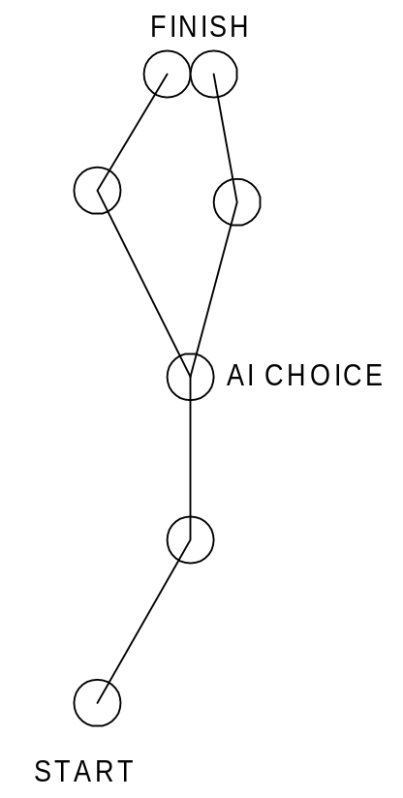
- Would need to lay down in Maya:
  - User start location
  - AI vehicle identity and start location
  - Checkpoints for user navigation?
  - Checkpoints (including choices as shown above) for AI path
  - Finish area as a rectangular collision volume
- Mission scripting tool lets is specify “hunt and destroy” missions; logic for AI vehicle spawning in code

Content

- TBD as part of the Vehicles section

Collectibles

Goals

- Simple – e.g., does not increase character animation scope
- Flexible – systems that can be re-used in many different contexts
- Payoff – collectible events that are satisfying in some way for the user will make the game feel less linear
- Easy to execute – simple, effective controls

Features – In Car

- Breaking things. Driving over a specific object (e.g., Mr. Burns mailbox because it contains Homer’s embarrassing letter) or one of a set of objects (i.e., like Road Rage missions).
- Pick up a passenger. Notes:
  - There are already two people in the car at all times. This feature means there can be three people in a car at once.
  - All vehicles should have at least 2, but ideally 3 seating locations.
  - Animation and dialog will be created for passenger-to-passenger interactions (i.e., in addition to passenger-to-driver).
- Graphical highlight or indication of collectibles. As well as being marked on the map, collectibles need to be highlighted on-screen (e.g., by glowing, or with a floating arrow pointing at it.
- Push N objects out of (not into) collision volume(s). Examples:
  - Push a load of Duff beer off the docks at Squidport (push an object out of a collision volume)
  - Note: The design choice that objects have to be pushed out of, and not into, collision volumes is deliberate – it is likely that pushing an object any distance with a vehicle would be frustrating

Features – On Foot

- “Touch and disappear” – useful for small objects (a box of donuts, an election chad, etc.). Touch an object and it disappears with a sound and HUD update.
- Graphical highlight or indication of collectibles. As well as being marked on the map, collectibles need to be highlighted on-screen (e.g., by glowing, or with a floating arrow pointing at it ala GTA3, etc.).
- Walk up to a door and use a camera fade (plus sound effect and HUD update).
  - For example, if Homer needs a Squishee, he could be sent to the door of the Kwik-E-Mart. When he gets to the highlighted zone, there is a screen fade or camera cut to imply the passage of time where the character went in/out of the store.
- Talk to a character - at the end of the conversation, the user gets an object (sound effect plus HUD update).
  - Could be a mission-objective (character and dialog specific to mission) or a bonus in a level (i.e., a character not shown on the HUD, that you can talk to any time in that level)
- Flipping switches – a highlighted location in the world cause the physics animation of an object to be turned on or off (specified in a mission script). For example:
  - Press a switch that causes an ferry to start running back and forth across an area of water
  - Press a switch that starts (or stops) a drawbridge going up and down
  - Such an event might be required by a mission, or it might be an optional thing that you can do in the game world
- Push a simple objects in the world as a trigger for a scripted event (e.g., bump a round boulder on a hill to start it moving – this triggers a pre-scripted event in the world – for example, opening a previously closed path)
- Get into another vehicle (see “Switching Vehicles” document)

Design Notes

- People didn’t like the simplistic “destroy N objects” missions much in Road Rage. It can be fun, but don’t overuse it.

Questions

- What about collecting large objects (a crate of Duff beer)?
  - Will “touch and disappear” work or will it look too fake?

Tools

- World-building:
  - Place characters for a mission, for dialog, character pickup, and/or logical object transfer (e.g., object collection might occur when you talk to someone, when you pick them up, or when you drop them off).
  - Place locators for breakable or movable object that user needs to hit:
    - Workflow notes – need a good workflow for this:
      - With naming conventions?
      - Automatic locators? (In some cases explicitly placing locators is redundant information, which leads to errors.)
        - Or automatic objects (i.e., place the locator, and the game puts an object there?)
      - Automatic trigger volumes? Manual placement of some trigger volumes that could be done procedurally.
  - Place rectangular trigger volume(s) that objects must be pushed out of. As with breakables, naming conventions should be carefully defined to avoid errors.
  - Place trigger volume(s) for passenger drop-off destinations
  - Place trigger volume(s) for “building door/camera fade” object collection (e.g., walking into the volume causes a specific presentation event - the camera cut/fade) and the logical collection of an object.
  - Place trigger volume(s) that turn animation of a physics object on or off.
  - Place drivable vehicle locations (both mission-specific and level-specific).

Content

TBD – collectible objects, animated physics objects, presentation sections, characters and vehicles, HUD, and sound.

Gameplay Controls

Goals

- Smooth driving controls that give you full control over the vehicle
- On-foot controls as simple as possible

Features

- Driving controls
  - Analog or d-pad steering
  - Analog gas and brake controls. Activated by any of the following:
    - Controller buttons (with analog support)
    - Right analog stick
    - Gas/brake pedals on steering wheel hardware
  - Counter-measure button
  - E-brake button (could experiment with analog input)
  - Taunt button
  - Horn button?
  - Experiment with controlling both steering and gas/brake on one joystick (ala Blood Wake)
- On-foot controls:
  - Analog movement, with the d-pad or analog joystick
    - Characters walk and run through this one control (i.e., move the stick just a little for walking). Or do we still need walking, now that we don’t have stealth AI?
    - Characters should accelerate to full running speed, and decelerate to a stop. The deceleration should include a character-specific animation (e.g., Bart sliding to a stop like Mario 64).
    - Most importantly, the control and animation should feel smooth
  - Manual camera control with the right analog stick. (See camera document.)
  - Do we need an “action button” to push “buttons” or interact with characters? Or is it totally automatic?
    - A button gives us the advantage of allowing on/off toggle switches (e.g., open a door, drive your car through, then close the door behind you?). Or would this be easier to do with two separate buttons? In other words, can ALL buttons have just one function? (e.g., open or close, start or stop)

Tools

- On-foot:
  - Tune the sensitivity of the controller (walk/run states, dead zone, etc.)
  - Tune penalty for 180 degree turns
  - Tune character acceleration/deceleration
  - Tune run/walk speed
- Vehicle:
  - Tune sensitivity of steering and gas/brake
  - Tune which buttons are used for gas/brake/e-brake/taunt

Switching Vehicles In Game

Goals

- A way of changing vehicles that doesn’t seem like car jacking (i.e., GTA 3)

Features

- The user starts a level as a walking character (even if loading a save game).
- A walking character can only get into a vehicle as a passenger. Therefore you will never control a vehicle that has less than two people in it.
- Implication – at least some vehicles will need to be able to carry a second passenger (see Collectibles document) and the sound system will have to be able to handle three-person conversations (logic TBD in sound document)
- The user gets out of a vehicle by pressing a button on the controller:
  - They can get out anywhere in the game world
  - The game will have to look for a “safe” exit location – a door not blocked by a static object or physics object
- Getting into a car is done automatically by walking up to any one of a drivable vehicle’s doors (except the driver’s door)
- Car entry/exit animation is done as follows:
  - Show the door opening
  - Camera cut combined with user instant-transportation to/from the vehicle. Don’t show character physically getting in/out of vehicles.

Tools

- Maya world-building – designers will place car start locations for a level. They reset upon game load from the memory card.

Mission Scripter

Mission Flow

A mission can be described as having two components:

- Sunday Drive. This component describes what the user does to launch a “gameplay mission start” event. The things you can be asked to in this context are:
  - Go to a person on-foot (triggers a conversation)
  - Get into a specific car (triggers a driver/passenger conversation)
  - Pick up a person? (triggers a walker/passenger conversation)
  - Drive a specific car to a location (trigger volume)
  - There can be more than one of these objectives in a Sunday Drive sequence
  - If there is more than one objective, then only the final one will launch the “gameplay mission start” event
- Gameplay. The Gameplay component has two things that Sunday Drive doesn’t:
  - A more comprehensive list of objectives that the user might have to complete (i.e., the Sunday Drive list is a subset of this one)
  - Failure conditions – gameplay ends in failure if various conditions are met (e.g., a mission timer runs to zero)

The flow of missions throughout a level is illustrated in Figure 1 – Mission Flow.

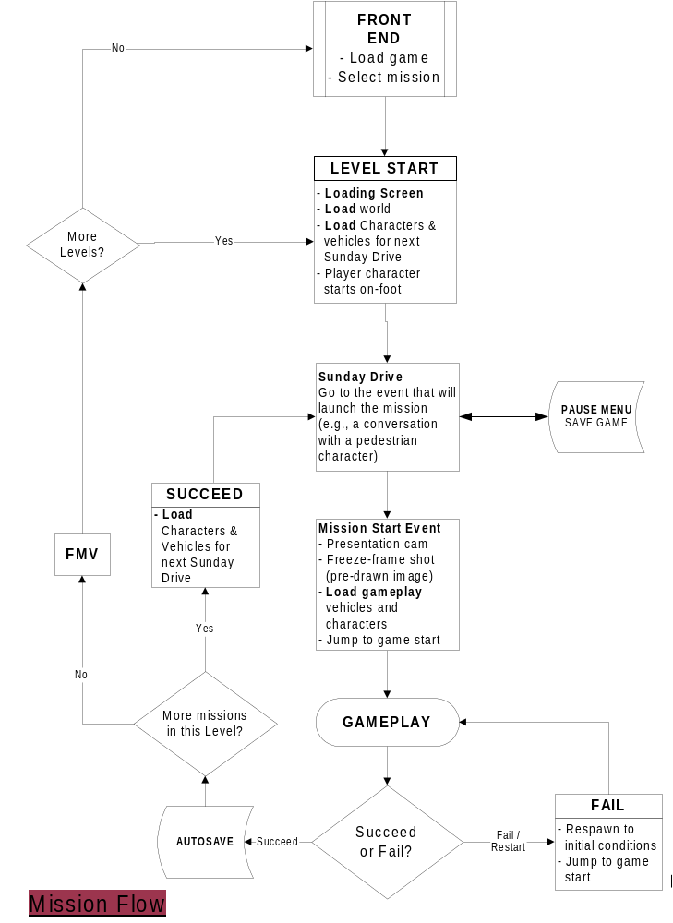

Figure 1

Objectives

Definition: An objective is something the user is asked to do. It is also defined as a discreet game state. In other words, an objective is independent of anything that happened before or will happen after it. (Objectives will appear connected to the user – but an objective definition contains all the information to set up a specified situation).

There are six basic objectives given to the user:
- GO TO [location | vehicle | pedestrian]
- PICKUP passenger
- DELIVER N [items | passengers] [TO| FROM] destination
- COLLECT N items
- DRIVE [vehicle] TO destination
  - Drive means you must be in the vehicle when you get to the destination – getting there on foot doesn’t count (GO TO is more general – you can walk or drive)
- FOLLOW vehicle TO destination
- DESTROY N [items | vehicles]

Sunday Drive Objectives

Sunday drive is a series of simple, linear “GO TO”, “DRIVE”, or “PICKUP” objectives. When the final objective is complete the mission-start presentation begins (see presentation document). These three directives can set up the four things that can launch a mission:

- Go to a person on-foot (triggers a conversation)
- Get into a specific car (triggers a driver/passenger conversation)
- Pick up a person (triggers a passenger/passenger conversation)
- Drive a specific car (or your choice of car) to a location (trigger volume)

Example One – Get in to a Car

Description: Get into Homer’s Car
Script:
GO TO VEHICLE Homers_Car //”Homers_Car” is a Maya
// locator
MISSION_START_PRESENTATION Homer // Focus the camera on
// Homer for the
// start-presentation

Example Two – Talk to Two People

Description: Bart (the walking user character) talk to Apu; then Moe
Script:
GO TO CHARACTER Standing_By_Kwik_E-Mart
GO TO CHARACTER Standing_By_Moes
MISSION_START_PRESENTATION Bart // Focus the camera on
// Bart

Notes:
- “Standing_By_Kwik_E-Mart” is a locator in Maya. The script needs to tell the game who is standing there, and what their dialog is.
- Do Sunday Drive missions also need a character [on foot] start location? That is, for when you load a saved game or select/jump to a mission?

Example Three – Get into a Can and Drive to Start Location

Description: Get into Homer’s car, then drive it to the School
Script:
GO TO VEHICLE Homers_Car
DRIVE Homers_Car TO School__L1M3_Start
MISSION_START_PRESENTATION Bart

Gameplay Objectives

A gameplay mission can use any objective. A big difference is that a gameplay mission has only one objective. If we want to link a DELIVER objective to a DESTROY objective, it would actually be two missions.

- GO TO [location | vehicle | pedestrian]
- PICKUP passenger
- DELIVER N [items | passengers] [TO | FROM] destination
  - Two types of delivery mission: SEQUENTIAL_ORDER (no choice of order – user gets the items in pre-determined order) or USER_CHOOSES_ORDER
- COLLECT N items
  - Just collect them, but without any delivery component
- DRIVE [vehicle] TO destination
  - Drive means you must be in the vehicle when you get to the destination – getting there on foot doesn’t count (GO TO is more general – you can walk or drive)
- FOLLOW vehicle TO destination
- DESTROY N [items | vehicles]
  - Two types of destruction mission: SEQUENTIAL_ORDER (no choice of order – user destroys the items in pre-determined order) or USER_CHOOSES_ORDER

There are two other additional components to a gameplay mission – failure conditions, and “other attributes” (game times and so on).

Failure Conditions

Failure conditions define what will result in mission failure. There can be more than one for a mission:
- PLAYER VEHICLE DESTROYED
- PLAYER VEHICLE DAMAGED
- PLAYER STRUCK BY VEHICLE WHILE ON FOOT
- AI_VEHICLE vechicle_name ARRIVES FIRST AT destination (i.e., it’s a race)
- TIMER N EXPIRED – N is the # of seconds initially on a game timer (if this condition is omitted, then there is no game clock displayed on the HUD)
- PLAYER GETS OUT OF VEHICLE???
- FAILURE TRIGGER VOLUME – a mission or level can have a trigger volume that causes the mission to fail; this is used for “out of bounds” areas such as large bodies of water
- Note: The game will have a “safety valve” whereby you can skip a mission after failing it N times (designers will tune the number N). This will be recorded in your mission completion status.

Other Attributes

Other things that a gameplay mission must account for:
- Mission setup data that refers to Maya world builder locators:
  - AI Vehicle identities and start locations
  - Player vehicle/on-foot start location
  - Character/Collectible content and locations, e.g.:
    - Apu is standing by the Kwik-E-Mart and talking to him represents collecting a Squishee
- Mission-specific dialog
  - Conversations
  - Mission-specific navigation dialog (e.g., a training line)
- Presentation triggers
  - Camera work and presentation (e.g., you trigger a switch – the game has to show you what you’ve done)
- AI settings:
  - Specify which AI Vehicles will be triggered by proximity?
  - Specify which AI Vehicles are enabled, based on mission conditions
    - e.g., Vehicles 1 through 20 may all be triggered by proximity, but after you’ve destroyed or pickup up an object then Vehicles 1a through 20a are also enabled
    - When you destroy or pickup another object then vehicle 1b through 20 b are also enabled
  - Specify how others AI vehicles are triggered, e.g.:
    - Vehicle 1 activation triggers vehicles 3 & 4
  - Set aggression, strength, and speed of AI vehicle(s) globally for the mission, or based on mission conditions (collectibles and destructibles), e.g.:
ON_COLLECT_2 AI_AGGRESSION_MEDIUM
ON_COLLECT_3 AI_AGGRESSION_HIGH
ON_COLLECT_2 AI_SPEED_HIGH
- TIMER - are there any things that will add time back onto the timer?
- STARING VEHICLE

Gameplay Example Objectives
The following gameplay script examples are taken from our first ten gameplay missions:

- Level 1: FOLLOW Marge TO Kwik-E-Mart
- Level 2: DELIVER 1 item TO destination
- Level 3: DELIVER 4 passengers TO destination
- Level 4 GO TO destination (race - failure condition is other vehicle getting there first)
- Level 5: DRIVE vehicle TO destination
- Level 6: DESTROY vehicle (start on-foot)
- Level 7: GO TO destination
- Level 8: DESTROY 4 items
- Level 9: Follow AI to destination
- Level 10: DELIVER 1 item TO destination

Real-time AI Scripting

There are a small number of things that the mission-scripter needs to be able to control in real-time, during gameplay:
- Activating certain AI cars on trigger volumes, or upon the activation of another specific AI car (which is activated by proximity)
- Activating or de-activating an animated bounding volume (i.e., turn on the ferry or a drawbridge, open/close a barrier, etc.)
  - Including dynamic physics-object bvs, such as a scripted vehicle
- Add time to the game-timer?
  - Do we need this? If so, what’s the associated presentation?
- Hide from chase AI?
- Pause/re-enable chase AI? (i.e., they come to a stop until you re-activate them at another script?)

Mission Design

Goals
- Gentle learning curve – the first missions should teach the user about the game
- Variety – don’t get stuck in a rut of one kind of missions
  - Use collectible types (e.g., conversations, world interaction, etc.) to mask the simplicity and repetitiveness of mission types
  - Utilize out of the car gameplay (e.g., a simple scripted chase)
- Chase AI (i.e., vehicles chasing the user) is the core of the gameplay
  - There are more interesting variations and AI tactics/defenses with the chase AI than any other mode

Level Order

Level 1 – Evergreen Terrace (Suburbs)
Level 2 – Squidport (Seaside)
Level 3 – Downtown
Level 4 – Power Plant (Industrial)
Level 5 – Squidport
Level 6 – Downtown
Level 7 – Power Plant (Industrial)
Level 8 – Evergreen Terrace (Suburbs)
Bonus Level – Halloween

Level 1 - Evergreen Terrace

Training – Missions 1 through 5

The purpose of these levels is to teach the user about basic game elements:
- Driving:
  - How to drive the car
  - Escape AI vehicles:
    - Follow an AI vehicle
  - Navigate to a place in the world (use the map)
  - Collectibles:
    - Pick up a passenger
  - Chase AI vehicles:
    - Using driving techniques (swerve through traffic)
    - Using world counter-measures (jump escape)
    - Using vehicle countermeasures
  - Advanced driving technique 1 – smooth accelerations
- On-foot:
  - Interact with a world object (push a button)
  - Initiate conversations
  - Find a bonus object out of the car
  - Get in/out of vehicles
  - Change vehicles mid-mission
  - Collect objects:
    - By talking to someone
    - By walking up to a door

Mission 1 (L1M1) – Drive the Car

Sunday Drive – How you get to the place that launches a gameplay mission.
Purpose | Learn how to:  - Walk  - Run  - Get into a vehicle  - Initiate a mission start
Description | - Start the game on foot near a vehicle  - User walks up to the vehicle, and gets in  - Driver/passenger conversation launches mission
Length | 60 seconds (with user run/walk experimentation)

Gameplay – Describes a gameplay mission
Purpose | Learn how to drive the car
Description | Follow a vehicle on an easy, casual route
Length | 90 seconds
Duration | 3 minutes (with 1 retry)
Challenge Level | Trivial – success depends only on controlling the vehicle

Mission 2 (L1M2) – Chase AI, Vehicle Damage

Sunday Drive
Purpose | - Learn how to navigate using the map  - Learn how to get out of a vehicle
Description | - Drive to a pedestrian character  - Get out of the car and initiate a conversation – this launches the mission
Length | 60 seconds

Gameplay
Purpose | Introduce chase AI and vehicle damage system
Description | Drive to a location, collect an object, and drive to another location to deliver it  - Collect an object by walking up to a door (e.g., the door of the donut shop)  - Light chase AI on the way  - Driving-evasion countermeasure (passenger suggests it?)  - Jump countermeasure on way back (i.e., jump to escape)  - User-vehicle destruction ends mission
Length | 120 seconds
Duration | 4.5 minutes (one retry, 30 seconds collecting object)
Challenge Level | Easy – avoid being destroyed

Mission 3 (L1M3) – Pick up Passengers

Sunday Drive
Purpose | Learn how to interact with a world object
Description | - Put the vehicle that launches the next mission behind a barrier of some kind; the user has to open by pressing a button?  - Mission 3 involves pickup up passengers; so maybe missions 1-2 use a two-seater, and the user has to get a bigger car here so they can pick up passengers  - Mission starts by driving to a location
Length | 60 seconds

Gameplay
Purpose | - Learn how to pick up passengers  - Learn about game strategy in the simplest form (e.g., choice of collectible)
Description | - Deliver 4 passengers, but there are 7 or 8 on the map – choose the ones closest to the destination to succeed
Length | 120 seconds
Duration | 7 minutes (two retries, 30 seconds picking up passengers)
Challenge Level | Medium – find the best route & passenger choices

Mission 4 (L1M4) – High Speed Starts

Sunday Drive
Purpose | Switch user to a very fast car for mission 4
Description | Mission starts by driving to a location
Length | 60 seconds

Gameplay
Purpose | Advanced driving 1 – the smooth/fast start
Description | - A drag race – need a smooth start to win (don’t spin the tires too much – need a dialog hint)  - Learn how to avoid traffic  - Keep them on a fairly straight road – don’t want to add the challenge of making turns in a race yet
Length | 30 seconds
Duration | 90 seconds (2 retries)
Challenge Level | Medium – learn the smooth start, and avoid AI traffic while driving at high speed

Mission 5 (L1M5) – Vehicle Countermeasures

Sunday Drive
Purpose | - Switch to an oil-slick vehicle  - Learn about in-car mission starts
Description | - Incorporate world interaction – need to press a switch to get access to the car  - Drive it to the mission-start location
Length | 90 seconds

Gameplay
Purpose | Learn about vehicle countermeasures
Description | - Give the user a light, fragile oil-slick vehicle  - Dialog tips on how to use it  - 90 segment chase AI segment  - Encourage them to switch to a tough vehicle with speed burst (i.e., make the second part of the mission very difficult unless they have it, and provide a dialog hint)  - User vehicle-destruction ends the mission
Length | 3 minutes (2 90 second segments)
Duration | 10 minutes (two retries, 60 seconds switching vehicles)
Challenge Level | Medium – survive an AI assault – easy if you’ve chosen the right vehicle

Missions 6 Through 10

Introduces the remaining game elements, and improve user proficiency in skills they’ve already used. Begin ramping up game difficulty level.

- New in-car elements:
  - Push an object
  - Break an object
  - Avoid scripted physics objects
  - Escape AI vehicles:
    - Disable vehicle (AI evasion pre-defined route style)
    - Disable vehicle (AI traffic style)
    - High speed car chase
  - Chase AI vehicles
    - Variable aggressiveness and density
  - Advanced driving techniques:
    - High-speed turning
    - Rally driving (driving on dirt)
    - Reverse powerslides (“Rockfords”)
    - Race
- New on-foot elements:
  - Strategic car switching/choice
  - On-foot gameplay/chase
  - Bonus object/celebrity

Mission 6 (L1M6) – Destroy an AI Vehicle

Sunday Drive
Purpose | Get user out of the car
Description | - Mission start is triggered by conversation with a pedestrian
Length | 60 seconds

Gameplay
Purpose | - Learn how to disable/destroy an AI vehicle  - Learn about damage HUD meter/interaction  - Learn importance of vehicle choice  - Learn about starting a mission on-foot
Description | - Escape vehicle is a little slower than your cars, but has a head start (i.e., you start on foot)  - Player has choice of two cars – heavy and slow (but with speed burst), fast and fragile  - Heavy and slow is the best choice – so put it a couple meters further from the player start  - Player starts on foot, and runs to one of the two cars, both of which are nearby
Length | 90 seconds
Duration | 5 minutes (2.5 retries, 30 seconds out of car)
Challenge Level | Easy – Medium; choose the right car and it’s not too hard

Mission 7 (L1M7) – High Speed Cornering, Race the Train

Sunday Drive
Purpose | Introduce walking/running skill element without time pressure
Description | - Drive/walk to the vehicle that will launch the next mission  - Make them walk on top of a high, narrow walkway that they can fall off of – this is training for later in the game where they’ll do things this while under time pressure  - Passenger/driver conversation triggers mission start
Length | 90 seconds

Gameplay
Purpose | - Advanced driving techniques 2 – high speed cornering  - Avoiding a scripted collision volume (with infinite mass)
Description | - The user has a fast that’s good at powerslides  - Drive to high speed and hit a wide-open 90-degree corner  - Dialog tip on how to do power-slide?  - A trigger volume starts the train running, which you can beat to the crossing only if you maintain your speed through the corner  - Race the train and beat it to the railway crossing to your destination in time
Length | 60 seconds
Duration | 3 minutes (three retries)
Challenge Level | Medium

Mission 8 (L1M8) – Destroy Objects

Sunday Drive
Purpose | - Launch a mission by picking up a passenger  - What if you go up to them on foot? Do pedestrians waiting for a ride need a “Go get some wheels” comment?  - They will also need a comment if you don’t have room for them (already have a passenger, or are in a 2-seater with no other passenger slot)
Description | - The previous mission could use a 2-seater, so this one requires getting another vehicle  - Implication for the HUD: Drivable vehicles should be represented on the map  - Mission starts by driving to a location
Length | 90 seconds

Gameplay
Purpose | - Learn about breaking objects  - Learn about navigation to choose the best path  - Learn about AI aggressiveness in response to your actions  - Learn how to do “Rockfords” (reverse powerslides)
Description | - You need to destroy 4 objects in the world  - You start pointed away from the first object, and an audio-cue tells you to “do a Rockford”  - Some items to break are in a dead-end, to encourage more use of this technique  - Each time you destroy one, the AI aggressiveness and density goes up  - Therefore the best order to hit them is not choosing closest to your start location – you choose the order so that the distance between destructible 3 and 4 is minimized  - User-vehicle destruction ends mission
Length | 2.5 minutes
Duration | 7.5 minutes (3 retries)
Challenge Level | Medium – Hard (AI will be very hard to evade if you don’t choose a good order to hit the destructibles)

Mission 9 (L1M9) – High Speed Chase

Sunday Drive
Purpose | Acquire a fast vehicle
Description | Mission starts with player/driver conversation
Length | 60 seconds

Gameplay
Purpose | - Keep up with a high-speed escape-AI vehicle  - Perform high-speed powerslides on dirt (“Rally mode”)  - Use countermeasure to keep a small number of AI vehicles off your tail
Description | - The AI vehicle is as fast as yours  - Get too far away and the mission fails (dialog cue? HUD?)
Length | 2 minutes
Duration | 6 minutes (3-4 retries)
Challenge Level | Hard (requires error-free driving over a long distance)

Mission 10 (L1M10) – High Speed Escape

Sunday Drive
Purpose | - Provide the user with a choice of vehicles (fast, large, or control)
Description | Mission starts by driving to a location
Length | 60 seconds

Gameplay
Purpose | - Intense chase-AI mission for a strong finish to the end of the level
Description | - Drive to a location (60 seconds) that is planned for on-foot gameplay:  - Pickup the object on-foot by “walking a rail” (could be the same rail you walked in the Sunday Drive session earlier)  - Include AI chase cars (police), more aggressive after you have the object – the best strategy is to save your countermeasures  - Get the object to it’s destination
Length | 3 minutes
Duration | 7.5 minutes (2.5 retries)
Challenge Level | Medium-Hard

Game Clock for Level 1

65 minutes total gameplay time for an average gamer for this entire level. A perfect run (no errors) would take 31.5 minutes.

Level 2 – Squidport

Mission 1 (L2M1) – Dump the Shipment

Sunday Drive
Purpose | Demonstrate the importance of vehicle choice
Description | - The user chooses between a fast vehicle and a tough one  - Drive to the starting line
Length | 1 minute

Gameplay
Purpose | - Introduce new gameplay element of pushing an object  - Introduce the user to more aggressive AI chase vehicles
Description | - Drive to the docks and push an object off of them  - AI pressure intensifies the closer you get  - Some shortcuts let you avoid  - Vehicle destruction ends mission?
Length | 2 minutes
Duration | 8 minutes (4 retries)
Challenge Level | Medium – Difficult

Mission 2 (L2M2) – Destroy a Group of Vehicles

Sunday Drive
Purpose | Introduce “goose chase” mission introduction style – talk to two different people
Description | Talk to two pedestrians to launch the mission
Length | 60 seconds

Gameplay
Purpose | - Introduce new gameplay element of destroying a number or roaming AI vehicles
Description | - Start on-foot  - Choose one of two vehicles (control or fast) during mission (i.e., under time pressure)  - Use the map to find and destroy vehicles  - Utilize an interactive world component (e.g., user having to start a ferry or rotating bridge)
Length | 2.5 minutes
Duration | 9 minutes (3 retries, 30 seconds choosing vehicles)
Challenge Level | Medium – track down the cars

Mission 3 (L2M3) – Run Bart Run

Sunday Drive
Purpose | Acquire the vehicle for a mission
Description | - Get a fast vehicle  - Drive it to a start location
Length | 60 seconds

Gameplay
Purpose | - Introduce on-foot chase element
Description | - Collect several objects  - Go to an on-foot chase area (the last collectible is there)  - Launch a scripted vehicle/object chase down an alley (or other area where there are no AI cars); user has to run around obstacles
Length | 3 minutes
Duration | 9 minutes (3 retries)
Challenge Level | Medium – Hard

Mission 4 (L2M4) – The Goose Chase

Sunday Drive

Purpose
Description | Have the initial conversation that launches the chase
Length | 1 minute

Gameplay
Purpose | Introduce the collectible mission style where the user has no choice of collection-order
Description | - Send the user on a goose-chase around the level, talking to one character after another or collecting items  - Make them use world interaction to succeed (e.g., some collectible or a faster car is behind a door of some kind)
Length | 3 minutes
Duration | 9 minutes (3 retries)
Challenge Level | Medium – Hard; requires efficient use of shortcuts

Mission 5 (L2M5) – A Race

Sunday Drive

Purpose
Description | Get to on-foot start location
Length | 1 minute

Gameplay
Purpose | Introduce a real race, with a light AI chase presence
Description | - A race around the neighborhood (be careful not to require AI cars to drive through complicated shortcuts or jumps, as they probably won’t be able to)  - Include light AI chase presence  - Note that races are A-B, not circuits – we have no logic or HUD for counting laps and such
Length | 3 minutes
Duration | 9 minutes (3 retries)
Challenge Level | Medium – Hard; should require use of at least some shortcuts (dialog hint needed)

Mission 6 (L2M6) – Drive on a moving BV

Sunday Drive
Purpose | Get the user into a fragile car
Description
Length | 1 minute

Gameplay
Purpose | - Learn to drive on an animated BV  - Learn to change cars to avoid a vehicle-destroyed damage state
Description | - Break some kind of objects – your choice of order  - With each one the AI becomes more and more intense  - The last one is on a ship or some other kind of BV that is moving as you are driving on it  - It is very difficult to survive the AI assault in one car  - Other cars are placed in fairly obvious locations for you to see  - You have to plan your switch so that you aren’t hit while out of the car
Length | 3.5 minutes
Duration | 10.5 minutes (3 retries)
Challenge Level | Hard

Mission 7 (L2M7) – Dump the Shipment #2

Sunday Drive
Purpose | Get the user into a fast & fragile vehicle
Description
Length | 1 minute

Gameplay

Purpose
Description | - Drive to the dam and push some objects off, without falling off yourself  - AI pressure intensifies the closer you get  - Vehicle destruction ends mission  - You can find a tough but slow car on the way there
Length | 3 minutes
Duration | 9 minutes (3 retries)
Challenge Level | Medium

Mission 8 (L2M8) – Car Chase, destroy a Vehicle

Sunday Drive
Purpose | Get the user out of the car
Description | Start the mission with an on-foot conversation
Length | 1 minute

Gameplay

Purpose
Description | - User runs around some obstacles to choose a car  - Or instead of an obstacle you might need to run on a balance beam kind of object  - Chase and destroy a vehicle before it reaches a place by the docks, the wharf, or onto a ship  - AI vehicles harass you along the way
Length | 3 minutes
Duration | 9 minutes
Challenge Level | Medium – Hard

Game Clock for Level 2

80.5 minutes for a typical gamer, 31 minutes for a perfect run.

Level 5 – Squidport

TBD

Level 8 – Evergreen Terrace

Mission 1 (L8M1) – A Race

Sunday Drive
Purpose | Get to the starting line
Description | - Choose a vehicle  - Go to the start  - Generic AI chase vehicles harassing you during the race
Length | 1 minute

Gameplay
Purpose | Start the level off with a race
Description | Win a race around Evergreen Terrace
Length | 4 minutes
Duration | 14 minutes (3.5 retries)
Challenge Level | Difficult

Mission 2 (L8M2) – Beat ‘em Up

Sunday Drive
Purpose | Get to start location
Description | Conversation with a pedestrian
Length | 1 minute

Gameplay
Purpose | Destroy a number or roaming AI vehicles (player needs some catharsis after a race!)
Description | - Start on-foot  - Choose one of two vehicles (strong or fast) during mission  - Use the map to find and destroy vehicles
Length | 3 minutes
Duration | 12 minutes (4 retries)
Challenge Level | Difficult – hard to catch them with the tough car, hard to destroy them with the fast one

Mission 3 (L8M3) – Beat ‘em Up 2

Sunday Drive

Purpose
Description | Choose vehicle – control or speed
Length | 1 minute

Gameplay
Purpose | More catharsis – psychologically prepare the user for the last four missions, which are the biggest challenge in the game
Description | - Destroy objects  - User choice of order
Length | 3 minutes
Duration | 9 minutes (3 retries)
Challenge Level | Medium – Find the best path, avoid chase AI

Mission 4 (L8M4) – The Balance Beam

Sunday Drive

Purpose
Description | Get the player to desired on-foot starting location
Length | 1 minute

Gameplay
Purpose | On-foot control mission
Description | - Start in an awkward place – you have to run on a narrow beam and not fall off, to get to a vehicle  - Drive to get an object (with chase AI)  - Includes a “race the train” component  - End up with another on-foot chase, running away from a scripted vehicle (or another balance beam)
Length | 3 minutes
Duration | 7.5 minutes (2.5 retries)
Challenge Level | Medium

Mission 5 (L8M5) – Deliver the Passengers

Sunday Drive

Purpose
Description | Pickup a passenger to start mission
Length | 1 minute

Gameplay
Purpose | Passenger delivery, with chase AI
Description | - Deliver N passengers  - User choice of path  - AI gets harder and more numerous with each pickup  - Vehicle destruction ends mission  - An alternate vehicle is hidden on the mission somewhere
Length | 3 minutes
Duration | 9 minutes (3 retries)
Challenge Level | Medium – Difficult; find the best path and/or an alternate vehicle (or maybe you require the alternate vehicle to survive – in which case we’d need a dialog hint)

Mission 6 (L8M6) – Catch the Race Vehicle

Sunday Drive

Purpose
Description | Get a vehicle to the starting line
Length | 1 minute

Gameplay
Purpose | Catch up to this amazing new vehicle (Car built for Homer?)
Description | - Chase the car through the city; keep up  - AI chase vehicle harass you during the chase
Length | 4 minutes
Duration | 12 minutes (3 retries)
Challenge Level | Difficult

Mission 7 (L8M7) – The Race

Sunday Drive
Purpose | - Acquire a specific vehicle (the Ferrini)?  - Choice of vehicle?
Description | - Get into the vehicle we want you to race with  - Go to the starting line
Length | 1 minute

Gameplay
Purpose | Acquire the new vehicle you’ll need for the last mission
Description | - Race the new vehicle – if you beat it, you win it  - AI chase vehicle harass you
Length | 4 minutes (around the neighborhood)
Duration | 12 minutes (3 retries)
Challenge Level | Difficult

Mission 8 (L8M8) – The Big Finish

Sunday Drive
Purpose | Get into new vehicle
Description | Get a special vehicle, which has both high-speed as it’s specialty and the speed-burst power-up (the Car Built for Homer?)
Length | 1 minute

Gameplay
Purpose | - Lead to conclusion of story  - End the game with a bang:  - Longer mission  - Most difficult mission  - NOT impossible or abnormally difficult – don’t “Pull a Driver” on our poor unsuspecting users!  - Give them things they haven’t seen before (new interactive world component, new vehicle)
Description | - Goose-chase around neighborhood with:  - Several conversations  - Intense AI with many chase vehicles  - Need to operate some kind of big interactive world object that they haven’t seen  - Big jump as a result, the biggest jump in the game – only the new car with a correctly timed speed-burst can make it (dialog hint needed)  - Jump provides access to the final collectible which leads to game-ending story
Length | 5 minutes
Duration | 15 minutes (3 tries)

Game Clock for Level 8

98 minutes for an average gamer; 37 minutes for a perfect run.

Appendix A - The Toolbox (Mission Components)
- Driving:
  - AI Chase vehicles (user has to evade them):
    - Using driving techniques (swerve through traffic)
    - Using world counter-measures (jump escape)
    - Using vehicle countermeasures
    - High speed chasing an AI vehicle
    - Ai cars get harder in reaction to user collectibles/destructibles
  - AI Escape vehicles:
    - Chase or follow an AI vehicle
    - Disable an AI vehicle, 2 types:
      - An evasion vehicle on a path
      - A group of vehicles roaming the world with AI traffic rules
  - Collectibles:
    - Pick up a passenger
    - Break an object
    - Push an object
  - Advanced driving techniques:
    - high speed cornering, powerslides, maximizing speed through braking and smooth accelerations, rally driving, Rockfords
  - Navigate to a place in the world (use the map)
    - route choice has strategic implications
  - Scripted or animated object/barrier:
    - E.g., a train
  - Racing? E.g.:
    - a drag-race to teach smooth acceleration
    - a race where you have to block the AI vehicle because they are simply faster, or have better cornering?
- On-foot:
  - Interact with a world object (push a button)
  - Engage in conversations
  - Find a bonus object out of the car
  - Get in/out of a vehicle
  - Changing vehicles mid-mission strategically
  - Collect objects:
    - By talking to someone
    - By walking up to a door
  - On foot gameplay/chase (use scripted object)

Appendix B – Mission Templates

Sunday Drive

Purpose
Description
Length

Gameplay

Purpose
Description
Length
Duration
Challenge Level
Bonus Ranking

I didn't see anything in the later missions to encourage the use of the rockford. A mission for learning/using rockfords is to have the player drive into a dead-end alley to knock something over (like a garbage can) then reverse out of it and spin around to keep driving. It would be a timed mission, and the player would need to do it at least 3 or 4 times in different alleys.

Multiplayer

Goals

Based on a mini-post-mortem of Road Rage multiplayer, we came up with the following goals:

- Keep the players close together
- More constrained chases – keep the players from separating or getting lost during chases
- Well hidden catch-up logic – keep the result un doubt as long as possible
- More life through character dialog
- Keep opponent visible (e.g., FOV, less speed, HUD, navigation system)
- Physics (collisions, damage, and driving) tuned for multiplayer
- Game data tuned for multiplayer
- Improved frame rate
- Keep it simple – fast, instant action
- Stay true to characters
- Cars move slower
- Balanced chase gameplay – make sure chasing player has fair chance to catch the escaping vehicle
- Design the game world to match these goals

Prioritized Features

- Game Mode: Basic CTF gameplay, with variable locations on the flag but one delivery location per player per gameplay session
  - Front end screen lets you choose your character/vehicle
  - The “flag” spawns like the passengers in Road Rage
  - Each player has one destination for a gameplay session (e.g., if you are delivering to the Kwik-E-Mart, then that’s where you’ll always take the flag)
  - You steal the flag by ramming the other player
  - First one to N flags wins
  - Delivery/pickup/steal mechanism the same as last year:
    - One touch pickup/steal/delivery
    - No tag-backs
- “Bullet Time” to create and emphasize player battlers. Components of this are:
  - slow-motion gameplay
  - fade-in transition from full speed to slow speed (and vice versa)
  - Screen blur visual effect accompanies transition
  - Game Logic/HUD, e.g.:
    - Three uses per vehicle, just like single-player powerups (the difference being that all multiplayer vehicles have only one countermeasure – bullet time)
    - User initiated with a button press
    - User’s get back a bullet time recharge (i.e., one of three uses recharges) by the following rules:
      - When the other user picks up the flag
      - When the other user steals the flag
      - When the other user is carrying the flag, and you drive for more then N seconds (tunable) and your bullet time inventory is empty
  - Countermeasure for escapee – some way to easily put the car on two wheels?
  - Tuning tools (amount of slowdown, transition time, recharge rule in code)
  - Sound – what happens in slow motion mode?
  - Camera lock – camera target is the other vehicle when in Bullet time
  - Camera – experiment with full-screen view in Bullet time
- HUD that shows other player (e.g., arrow over their car in the game world)
- Better way of showing who has the flag – vehicle glow or f/x, as is used in first person shooters?
- Taunt button
- No navigation arrow – navigate using the map, and by keeping the other player visible
  - Or do we need a crow-flies arrow or some other way of letting you know where your opponent is?
- Damage system could be catch-up logic – person with flag more susceptible to damage
- AI traffic as catch-up logic – more traffic (or more bad drivers) in front of flag bearer

Question
- What are ways that we can incorporate FPS-like CTF strategies and world design?
  - Choke points in the map
  - Choke points under user control – e.g., a switch that raises a drawbridge
  - Physics-based traps you can spring on other player? Block a way?
  - Keeping the vehicles visible as much as possible – open, small world
  - Incorporate vehicle counter-measures like oil slicks?

Tools

Some of the tools designers would need to create this gameplay:
- Maya world-building tools:
  - Place base(s) – two per level?
  - Place flag spawn-locations
  - Place drivable vehicles start locations
  - Place 2 character start locations
- Game-tuning tools:
  - Game rules in code – revise rules based on stationary base
  - Tune counter-measures:
    - Effect (e.g., size of oil slick or smoke screen)
    - Bullet Time (amount of slowdown, transition time, recharge rate, bonus recharge values for special moves like jumping

Prioritized Content List

- Downtown single-player level design includes a “sub level” – a piece of the level that can be blocked off and used for multiplayer

Features of the world:
- Jumps
- Interactive – drawbridges, doors that open & close
- Collectibles strategically placed (e.g., speed burst power-up near bases)
- Chaseways (e.g., long corridors such as bridges that give an advantage to the chaser)
- Small and constrained
- Flag objects (TBD)

Driving Model

Goals

- More fluid and natural feel, and reward skilled/experienced players
  - Less tight and twitchy
  - More natural turning/steering
  - More sliding, finer gas/brake control
  - Less “floaty”
  - Not too loose (e.g., Wreckless)
  - Midtown Madness 2 is a good example of the driving feel
- A sense of danger – that feeling that you are on the edge of danger when driving very fast
- More exciting and realistic collisions
- Don’t let the car get stuck
- More variation between vehicles, including vehicle speed
- Trick moves (e.g., drive on two wheels)
- AI cars perform more like user car
- Exciting jumps & big air
- Balanced and tuned physics for multiplayer

Features

- The new driving physics; the new and improved “feel”
- Cleaner, more effective powerslides (close to the one-button touch to initiate slide of Driver)
- Initiate sliding with physics & steering, not just with handbrake
- Technical question – investigate possibility of “rally mode” driving on dirt surfaces
- Analog gas/brake controls:
  - GT3 control option – right stick for full analog has/brake
  - Support two states on button gas/breaks - “hard button press” and “soft button press”
  - Experiment with using one stick for both steering and gas/brake (see XBox Bloodwake for example)
- Full physics simulation on AI cars in accidents
- Suspension physics or animation on nearby AI vehicles
- Special moves:
- 2 wheel driving – some way to get the car up on 2 wheels (maybe while in Bullet Time?)
- “Break stand” – a way of doing peel outs
- Donuts
- Speed Burst (see “Chase AI” document)
- Getting unstuck & collision recovery:
- Automatic tank mode when driving into a wall or collision volume with steering and gas pressed, and the car isn’t moving – user won’t have to reverse. See Midtown Madness 2 (with car in automatic transmission mode) for example.
- Reverse power slides – it’s a high priority to get smooth reverse powerslides as a satisfying way to pull a 180. See GTA3 taxicabs for the quality benchmark.
- The “Weeble effect” to make cars land upright without limited their degree of motion.
- Exciting jumps – with the slower car, and maybe they’re heavier too, be careful not to make jumps too small

Tools

- Tuning tools – cars can be easily tuned (with slider-like controls) in four major categories. The variables will be as independent as possible.
  - Top Speed
  - Acceleration
  - Handling/Stability
  - Mass & strength

Dialog System

Dialog Goals

- Emphasis on character relationships and dialog
- More variety in dialog
  - Re-use Road Rage, Skate, and celebrity re-use rights to provide variety
  - Give priority to using new lines first; supplement them with Road Rage/Skate lines
- More lines based on relationships
- Expand relationship dialog system to incorporate
  - 3rd passenger in-car
  - On-foot encounters
- Technically less demand on the load system – more predictability in character and/or dialog selection
  - Prioritize different types of dialog (e.g., “Must Play Lines” and “Optional Play Lines”)

Definitions

- A conversation is a series of lines between two characters.
- A one-liner is a standalone line of dialog uttered in response to a game event. Each one-liner implies a dialog set – a group of 1 or more lines associated with a particular event. If there is more than one line in the set then the game chooses from the lines randomly.
- A walker is a player the user can control on-foot. They can also get into vehicles as a passenger.
- A passenger is an NPC (Non Player Character) that can get into vehicles. A walker and a passenger can both be riding in a vehicle at the same time.
- A pedestrian is a character in the world that walks around or stands in one place.
- A driver is a character who drives a car.

There are four types of dialog:
- MPL. Must Plan Lines. These lines are always played. If another line is playing when a MPL event occurs then the MPL line is queued.
- MPI. Must Play Immediately. Used for animation-specific events such as falling or being hit by a car. Any currently playing dialog is cut off and the MPI dialog is played immediately.
  - Note – NIS dialog probably has to be MPI, so that it matches the NIS presentation.
- SPL. Should Play Lines. If other dialog is being played, the OPL event is queued with a lifetime of a few seconds (to be tuned). If the lifetime expires (i.e., while other dialog is playing) then the dialog event is ignored, so that the dialog itself is not separated from the event that triggered it.
- OPL. Optional Play Lines. These are just like SPL, except that optional lines are not triggered every time a given event occurs. For example, not every vehicle damage event should result in dialog, or the characters would never shut up.
  - We’ll need tuning tools to determine how often these lines play (Marc B & Darren E to specify tuning tools?).
  - Ideally, the game would avoid starting an OPL in situations where a MPL line is about to play (e.g., don’t start an OPL in the last ten seconds of a mission, since you know you have to play mission failure/success dialog and presentation).
    - TBD: What are these rules?

Conversations

There are two types of conversations:

- Mission specific. In these conversations we know in advance which two characters are having the conversation, what they will say, and when they will say it. This implies that the world builder tool will include a way to link mission-specific events to specific dialog conversations. Mission-specific conversations are MPL, since they will convey important information to the user.
- Relationship conversations. You won’t necessarily know which character will be involved in advance, so the game will have to know which characters have relationship lines for each other. There is more than one conversation per character relationship pairing, so the game chooses the conversation randomly. Relationship conversations are SPL.

The events that can trigger a conversation are similar (though some are exclusive to mission-specific). If a given event has specific dialog associated with it then that mission-specific dialog is played; otherwise a relationship dialog event is triggered. The triggers and conversations participants are:

- Walker/Driver triggered on walker vehicle entry.
- Walker/Driver triggered on mission objective complete.
- Walker/Pedestrian triggered by proximity to the pedestrian.
- Walker/Passenger triggered on passenger vehicle entry.
- Walker/Passenger triggered on mission objective complete.
- Walker/passenger triggered by a trigger volume (e.g., driving through a particular space in the world). Mission-specific only.

For relationship conversations, either participant may start the conversation. For example, Homer may walk up to Bart. The dialog includes conversations initiated by Homer, and others initiated by Bart. The choice of which to play is random.

In Car One Liners

Driver/Walker/Passenger

This dialog is OPL. The game will randomly choose which of the three people in the car will speak, and choose a line from the dialog set. The trigger events are:
- Big air – vehicle jump of a certain magnitude
- Minor crash (no damage, such as hitting a breakable or low-speed collision)
- Crash causing vehicle damage
- Big crash (e.g., head-on collision causing maximum single-hit damage)
- Near miss accident
- Near miss on pedestrian
- Reaction to hitting a pedestrian
- Car destroyed (implies a few second time penalty before it resets)
- Running out of time in mission (“negative“ Skate dialog?)
- AI chase vehicle closing the gap (“They’re gaining on us…”)
- AI escape vehicle widening the gap (“They’re getting away…”)
- Location-based trigger to comment on something in the world

Walker Only

MPI dialog (i.e., it must match presentation):
- Mission start (in-car)
- Mission start (on-foot)
- Mission victory
- Mission failure

SPL dialog:
- Training lines for the driver, triggered by trigger-volumes placed in world builder by game designers. Mission-specific:
- Smooth starts
- Powerslides (reaction to under-steer into crash)
- Cornering (reaction to under-steer into crash)
- “Rockfords” (reverse 180 powerslide)
- Passenger pickups (how to do them)
- Get too far away and the chase-mission fails
- How to evade pursuers
- How to use countermeasure
- Telling you to switch vehicles
- Instructions to the driver, triggered by trigger-volumes placed in world builder by game designers:
- Turn left
- Turn right
- Go straight
- Turn around
- Go up the hill
- Go down the hill
- Take the jump
- There’s a shortcut
- You’re going the wrong way
- Stop

OPL dialog:
- Exit vehicle
- Reaction to destroying an AI vehicle
- Reaction to using a vehicle counter-measure successfully
- Reaction to using a vehicle counter-measure unsuccessfully
- Race comments (relationship specific?):
  - Pass an opponent
  - Get passed

Driver Only

- Driver car descriptions (e.g., fast and fragile, great control and balanced, or a slow tank). SPL.
  - Plays after the walked/driver conversation the first couple times you get into a particular vehicle? Or triggered by proximity when you aren’t near enough to a door to get in?

Passenger Only

SPL:
- Exit vehicle

On-Foot One Liners

Walker Only

MPL dialog:
- On object collection (object/mission specific)
- On world interaction (reaction activating a button)

Animation Based. Event is in sync with corresponding animation. MPI; must play immediately – cut off other dialog if necessary (i.e., it will look wrong if you are gabbing away and fall or get hit by a car and you keep talking):
- Idle
- Fall
- Get up
- Reaction to running into static
- Reaction to running into character
- Decelerate and turn 180 degrees
- Dodge car (the car missed)
- Hit by car
- Hit by pedestrian (e.g., two people bumping into each other)

Passenger/Pedestrian

OPL dialog:
- Dodge car (the car missed)
- Hit by car
- Hit by pedestrian (e.g., two people bumping into each other)

Passenger Only

MPL dialog:
- Get some wheels (i.e., if you walk up to them on-foot)
- “I can’t fit in there!” (i.e., if you drive up to them and there’s no free passenger spot)

Pedestrian Only

MPL dialog:
- Get out of the car / I want to talk (i.e., if you drive up to a pedestrian who wants to have a conversation)

Multiplayer Events

MPL dialog for multiplayer-specific events:
- Flag pickup
- Flag delivery (score)
- Steal or pickup the game-winning flag
- Steal the flag
- React to stolen flag
- Win game
- Dialog for bullet-time?

MPI dialog:
- Taunt
  - User initiated
  - Specific to game context, four situations:
    - Losing
    - Winning
    - Game is close
- Carrying winning flag

Sound

Goals
Emphasis on character relationships and dialog
  - Expand dialog system to incorporate 3-way conversations
  - More variety in dialog - more lines based on relationships
Thematic music – specific music for each playable character (e.g., stingers at the Road Rage game-over event) chase music
Use sfx and ambient sounds to create more dynamic worlds.

Voice

Direction
The character’s voices were a big part of the game’s success. Our goal is to improve and add to that feature. The game designers have outlined the high level design such as:
- 3-way character conversations
- Passenger-to-passenger interaction
  - Passenger-to-driver interaction
- Character relationship dialog for pedestrian events
- Characters dialog that recognizes world locations
Voice is certainly the most important sound feature if not the most important aspect of the Simpsons license itself. The technical demands for the voice in the original game were huge. We must design the voice in a way so it is more predictable in terms a sequence of events so the system knows which line of which character needs to be loaded at any given point. Having a hierarchy such as the “must play lines” and the “optional play lines” would help make the sound system more efficient and allow us to allocate sound resources to other important sound assets.

Type definition
Finale design TBA

Driver character

Passenger character

Pedestrian characters

Implementation / Tool requirements
In order to maximize the sound in the game the dialog system must be categorize properly.

Driver character

Passenger character

Pedestrian characters

H2H

Voice Data management

PS2, GC
On the PS2 and GC, it will definitely need to be done dynamically with 2 buffers (more if we can) The game would have to anticipate and load data ahead of time to play on the demand. If loading can not be done ahead of time, a delay of up to 1.25 second.

X-Box
The X-Box has the advantage of the hard drive which we hope to use for dialogue.

Scripting Tool:
We will not be using any special tool for the dialog. Once the naming convention will be established the sound programmer will write a program that will parse the files and do all the conversion for all platforms. We will use RadTuner to test, trigger and tune the dialogue content independently from the game triggers. In the same tool we can tune levels and control variance in the playback.

Risks / Concerns / Problems / Solutions

Scheduling
Scheduling of the voice talent, recording and editing is the most significant dependency of this game. We rely entirely on FOX for this and we have no control. It is imperative for FOX to schedule the voice talent recording sessions as early as possible to make sure the game will not be delayed.
Note: Recording must be done by September 15th, 2002.

Localization:
The assumption is that we will receive edited sound files ready to add to the game. We will do the mastering of the voice only.

Car sfx

Direction
The overall direction with the car sounds remains the same as it was in Road Rage. The intent is not to simulate a real car, but rather to create a fun and responsive driving experience.
We will be looking at improving the current engine code. We will likely re-use previous engine sounds but we will create new engine sounds appropriate for each of the new cars type and size. The main distinction will be in the performance and the car upgrade features, we will tune the cars for each incremental levels of performance.

Type definition

Engine sounds
Here are the parameters for the engine sound system
- Trim (master volume)
- Max volume
- Min speed (minimum speed required for playing a sound, i.e. surface sound of gravel will trigger only if the car is moving)
- Pitch increase (maximum pitch increase)
- Pitch decrease (minimum pitch increase)
- Looping (on/ off)
- Engine “normal” RPM (establishes the reference RPM value at which the engine sound wave will play non altered)
- Decay time
- Delay time
- Attack time
- Inside cone angle
- Outside cone angle

Road surface
tires on dirt, water, grass surface etc.

Skids, tire squeal
peel out (tire squeal sample for a peel out)
skid (skid sound used for hard turns, spin outs and sudden stops)
hand brake
normal brake
donut

Car horn
horn (sound of the car’s horn)

Implementation / Tool requirements

Engine sounds
Although most of the cars will use different samples, they will all have the same four components.

Road surface sample
Surface detection, surface id

Skids, tire squeal
There are only two types of skid sounds that will be used. Skid and peel out sounds will be global across all cars.
The first type is the peel out. The peel out sound will behave in a way such that it gets louder as the wheels spin faster.

Peel out sample

Car horn
Each car will have it’s own horn sound. There will be only one horn sound per car. Depending on the car, one of two kinds of horn samples could be used. Some of the cars will have a one shot sample assigned to the horn. This means that if the player holds down the horn button on the controller, the horn sound will play until it reaches the end of the sample, at which point it will stop. The other kind of horn sound will use a looping sample. This will be used for some of the more obnoxious characters in the game (such as Homer or Barney). The looping sample will allow the user to hold down the horn button and have the horn play for an indefinite period of time.

Risks / Concerns / Problems / Solutions

SFX

Direction
The sfx will done in the traditional cartoony style, over the top but always in check with the TV series. There are a number of episodes to which we will refer to assure consistency with the TV show.

Type Definition

Collision Sounds
Those are basically all the impacts sound. The samples will be organized in categories of wood, metal and glass crashes. We will combine the various samples for the various types of objects.

Small objects
Wood crates, park bench, mailbox, fire hydrant, and garbage cans, etc.

Immovable objects etc
Building, trees etc.

Landing
Car hitting the ground with a bouncy springy sound.

Collision with other cars

Generic Driving sounds

Road surface
Driving through water, grass, dirt road

HUD sounds
Game timer, collectible status, countermeasure use, vehicle damage status

AI car sfx

Simple Engine sfx, car horn, tire squeal. Refer to car section for more details.
The difference here for those sounds is they attached to a moving object controlled by the AI.

Implementation

Collision Sounds
Triggering condition: collision + object id
Control: volume to speed of car, position
In the case of the landing sequence, we have to find out if it is an canned animation or controlled by the physics of the car.

Generic Driving sounds

Road surface
Triggering condition: surface detection
Control: depending if speed is constant on those surfaces

HUD sounds
Triggering condition: HUD id object + condition TBA
Control: none

AI car sfx
Triggering condition: car id object + proximity
Control: Doppler fx (pitch, volume to velocity) , position

As far as the horn of AI cars we will to see if we want to figure out how to do this with individual cars or just when crossing busy intersections.

Tools requirements

Audio for Run-time collision physics system
The random variability of a collision simulation is graphically stunning but it is the variability that makes traditional game audio applications ineffective. A single ‘canned’ sample triggered with each simulation will never be synchronized with the graphic and seem wrong because the audio is fixed while the graphic randomly varies.
We have recently developed audio support for our run-time collision physics system. The system relays info pertinent to audio such as the behaviour of the objects, land, bounce, spin, slide, roll and also the geometry, as which part of the object as collided. Based on that info we are then able to associate sounds with each object type and have sound matching the dynamism of the collision.

Risks / Concerns / Problems / Solutions
If the Ftech support for the run-time collision physics isn’t completed on time we would have to revert to the more traditional approach of canned collision sounds.

Music

Direction
The music will have a more important role to play to help telling the story and support the presentation. In Road Rage, the music was more incidental and it was played back as a jukebox. This time we will associate specific music tracks with specific missions and have more music written for each of the playable characters.
Search and explore music, the in-between mission music will need to be fun foot tapping music in a style that would suit each of the 8 playable characters (very much like what Chris Tyng did for the game over short stinger in a musical style representative of each of the character, but this time in full length pieces of music)
For instance, when you play Lisa some kind of jazzy saxophone music plays until her mission kicks in, at which point a more dramatic music track would then be cued according to the mission level and intensity. There has to be a clear distinction between the search and explore mood and the mission music. We could very well re-use music from last year for the chases since it is doubtful we will be able to get 20 new songs for the game.
The personalized short stingers from Road Rage could also be re-used, new ones would need to be created for the new characters. They were created for the game over segment so we would need also need a “victory” version of each of those. There would be eight mission failed stingers and eight victory ones – one for each controllable walking character.

Type definition

In-game Music
The various mission will require different type of tracks.

Search and explore
2-3 tracks written for each character. Music style that would suit the 8 playable characters.

Chase music
10-12 different chase type music with various level of intensity. Most tracks done for Road Rage would actually be better suited for this year’s game.

Short stingers

Mission succeed / fail
Unique succeed and fail music stinger for each of eight playable characters

Win H2H
2-3 short stinger when you win in H2H

Implementation

In-Game Music
The music should be coded to work in jukebox style. No particular order, flag the tracks once they are played, play all other tracks before playing the same one.

Win H2H
Play the short win stinger with the winning sequence

Unlock screen
Play the short music stinger when unlocking something

Risks / Concerns / Problems / Solutions
As always, dealing with an external composer has the potential in delays and not getting what we require for the game. This time around we should try to have direct contact with Chris Tyng to ensure we do get the right music and have a chance to review and hear the work in progress early enough so we can give him feedback on how it works in the game.

Front End

Direction
The current game design has a minimal Front End. We will have a short title track (30-45 seconds?) depending on the final story; the music could be thematic to set the tone of the game.

Type definition

Navigation sfx
Select, scroll, back, cancel, reject (for locked up levels)

Implementation / Tool requirements

Navigation sfx
Triggering condition: joystick input, screen #

Cheats:

Triggering condition: cheat fail, success

Risks / Concerns / Problems / Solutions
None

Ambient and Landmark Sounds

Direction
We are currently considering having no music when stepping out of the car. The music would then be replaced but an ambient track such as city ambience, ocean sound with seagulls for the Squid port etc. This would help make the game more dynamic and more alive than having music throughout the game. (We could possibly use minimal and sparse underscore kind of music)
Adding landmark sounds and world-based sound would greatly help to make the environment alive as well.

Type Definition

World based sounds
Such as water falls, nuclear generator etc.

Landmarks sounds
Those are soundbites we will associate with specific buildings in the world. They will be about 10 seconds long, one shot samples.

Implementation / Tool requirements

World based sound
Those sounds are loaded in a buffer and played based on the proximity of the object. Those type of sounds are expected to always play (i.e. driving close to a water fall should always be heard)

Landmarks sounds and other ambient sounds
These sounds are also played through a buffer system however they don’t have to play every time. (probably should not, unless if it is desired as in the crow sound when entering the nuclear plant compound) An example of as sound attached to a landmark would be the school bell. Driving by the school you occasionally hear the school bell ringing etc. Other types would be generic sounds to be triggered randomly such as dogs barking in the suburbs, birds etc, those types are associated with a neighborhood and are triggered only if nothing else are a higher priority is required. These types of sound enhance the worlds but they are lower priority and should always be secondary if dialog is required to play.
Triggering condition: proximity to a sound making landmark + landmark id
Control: Doppler fx, 3D positional (panning)

Tools
The easiest way to implement this is to use the model developed in Dark Summit. With the aid of a debug camera, the sound designer is able to navigate anywhere in the world and display the names of objects. Then he can edit the object file and associate a sound with any desired object. The sound gets loaded and unloaded automatically as he approaches and leaves the given object.

NIS / FMV

Direction
There will be 16 FMV that will play at the beginning and end of each level.

Type definition

Intro
Intro NIS to the level

End of level
End NIS of the level

Implementation / Tool requirements
None

Risks / Concerns / Problems / Solution
See voice Risks section
The animators will need to animate to the recorded dialog. Which means they can’t finish their work until we have received the files.
Another consideration is the localization of those FMV. For the best result, all the languages would to record to the finished FMV which might not be possible.

Memory management

PS2
Here is the current plan for managing the sound memory on the PS2.
RAM = 2 MB of compressed data 4:1 (so close to 8 MB
Hard drive= No
Multiple CD streams= Possibly
- One partition for universally used sfx (collisions sfx, AI cars, HUD, etc.)
- 4 buffers, 2 for loading dialogue (one passenger, one driver), 2 for landmarks sfx. Don’t exactly yet what we will do in H2H since it will depend on the dialogue design. (more buffers if we can)
- Car sfx bank (budget the space for the largest bank X 2 to cover for H2H)
- Hopefully 2 CD streams, one for music the other for ambience

X-BOX memory management
The access to a hard drive will help us greatly on the X-BOX. Memory in this case could be divided as such.
RAM = 8 MB ( hopefully, less if can cache from hard drive)
Hard drive= Yes
Multiple CD streams= DirectMusic is supposed to allow this easily

- One partition for universally used sfx (collisions sfx, AI cars, HUD, etc.)
- Instead of using buffers for loading and playing dialogue, landmarks sounds, we could put on the hard drive and cache the data.
- Car sfx bank (budget the space for the largest bank X 2 to cover for H2H)
- Hopefully 2 buffers for CD streams, one for music the other for ambience

Additional Features

Reverb
We will use reverb and other DSP capabilities to process sounds when going through tunnels. For this we will need to create groups of sfx. For instance, a car + voice of the driver (and passenger if it applies) should be grouped together so if the player goes through a tunnel, sounds triggered by that car and the voice of its occupants will be processed with reverb accordingly and independently from the music or the other sound triggered say by another player in H2H.
We now support reverb for all the platforms.

Dolby Surround
Dolby Surround is a well-known multi-speaker playback system that requires special encoding as well as additional hardware at the user end to be able to experience it. This method is “canned”, perfect for movies but not design to be interactive.
The X-Box however, supports real-time surround encoding and this is done by the hardware. There is no extra work to do to support that feature. For example whenever a car is behind you the sound will be automatically played through the back speakers of the surround system. Of course, to experience this feature the X-Box must be connected to an amplifier with a built-in surround sound decoder like most entertainment system and have the proper speakers setup.
The other platforms do not support it and therefore will not have real-time surround sound.

R & D / Prototyping / Focus groups

Presentation

Goals

Major goals:

- Choose a style for our game (e.g., the movie “Snatch”) and use it throughout
- Utilize The Simpsons style as well
  - Camera cuts rather than camera swoops
    - Be careful to maintain continuity and context between cuts
  - Short scenes – camera changes every 5 seconds (or less – subject to research/analysis of Simpsons style)
- Camera composition and purpose
  - Use the camera purposefully – no floaty, meaningless camera swoops
  - Show off the world – use conversations and other presentation elements to frame the better world art

Minor goals:

- Better tools – plan and coordinate roles of artists, designers, and coders
- Don’t violate TRC requirements – specifically, everything can be paused
- Allow movies to be skipped (possibly with a confirmation overlay, as in Jak & Daxter)
- Fully specify HUD animation
- Use sound to augment presentation – for example, stylized sound effects for slow motion and accelerated-time shots; see The Matrix, Snatch, and Max Payne as reference examples
- Don’t use cuts on world interaction presentation – need to show relative location to the user; do use presentation style though – for example, the accelerated-time + slowed-time cuts used in Snatch

Content

- The movie “Snatch” as the presentation style of the game
- Simpsons theme during transition
  - Character specific music
  - Short transitions
  - Keep scenes under 5 sec
- Camera styles include:
  - Multiple cuts
  - Zoom in and out
  - Pans
  - Tracking
  - Camera rotation (camera spine)
- End of mission transition
  - Skid to stop
  - Victory/failure animation – could use a camera cut and place the character outside of the vehicle
  - What about the transition back to mission start location?
- Investigate high resolution models for NIS
  - How long to load?
  - Will it fit with the presentation style?
  - Don’t sacrifice presentation style for higher resolution art
- Facial animations for conversations under procedural control:
  - Mouth flapping
  - Eye blinking

Features

MAIN STORY – pre-rendered.

Level (Episode) start and end - pre-rendered.

Mission start - procedural

- There are approximately 75 possible missions
- Darryl will look into a snapshot image ingame held in memory for a few seconds. And in black and white.
- Possible Scenarios
- Talk to character
- Get into car
- Pick up passenger
- Drive car to location
- Presentation ideas
  - Screen blur
  - 2D (monotone) image
  - Mission title
- After mission start dialog
  - Dissolve to:
    - 2-3 second camera pan
    - Sound effect (to signify mission about to start)
    - HUD appears

Mission Success - Procedural

- In car
  - car will skid to stop
  - 90 degree turn to highlight passenger (User)
  - Possible scenarios
    - camera cut
    - camera rotation
    - text on screen
  - Slight pause to load
  - dialog
  - character specific animation
  - Sound F/X

Issue: roof

- Out of car
  - Text
  - Slight pause to load
  - Character specific animation
  - Dialog
  - Sound F/X

MISSION FAILURE
- In car
  - car will skid to stop
  - 90 degree turn to highlight passenger (User)
  - Possible scenarios
    - driver kicks you out of car
    - car explodes
  - camera cut
  - dialog
  - character specific animation:
Issue: roof

- Out of car
  - Text
  - Character specific animation
  - Dialog
  - Sound F/X

CONVERSATIONS (100 -150 conversations)

There are two types of conversations:

- Simple quick dialogue that really doesn't pertain to gameplay
  - In game
  - No camera change
- Key mission objective dialog. Conversation between charaters where they are getting information on gameplay hints.
  - In game
  - Player can leave conversation
  - Procedural
  - Camera presentation effects
    - Cut
    - Zoom
    - Boarders

Issues:
- In order for this to work, technically the characters have to be in position for the dialogue to trigger (also, some sort of indicator or highlighter)
- Issues of objects may obstruct the camera view, solution would be to make sure objects do not exceed passed the camera height where the major dialogue takes place.

World interaction and trigger result

COUNTER-MEASURES

MULTIPLAYER

Tools

- Support Maya cameras? Would allow for iteration on camera movements in Maya.
- Designer/artist placement of cameras that are controller procedurally:
  - Cut cameras on jumps
  - Conversation cameras
  - Mission-complete presentation

Character Animations

Idle Animations:
Homer:
- Scratch head
- Scratch bum
- Fall asleep
- Burp

Marge:
- Adjust hair
- Twiddle fingers
- Pull something from hair

Apu:
- Adjust jacket
- Comb over hair
- Tap foot
- Pull up pants
- Levitate

Grampa:
- Fall asleep
- Feel sorry for himself

Bart:
- Cross arms (inpatient)

Lisa:
- Tie shoe
- Look at watch (but no watch)
- Yoga
- Swat fly

Ralph:
- Pick nose
- Pick up “bug”
- Pick ear
- Fingers in mouth

Milhouse:
- Has to pee
- Adjust glasses
- Adjust underwear
- Laugh

Mission Failure (on-foot)
-dialog
-character specific animation
Homer

Marge

Apu

Grampa

Bart

Lisa

Milhouse

Ralph

Mission Failure (in Car)
-car will skid to stop
-90 degree turn to highlight passenger (User)
-Possible scenarios
-driver kicks you out of car
-car explodes
-camera cut
-dialog
-character specific animation:
Homer
- Bash head against steering wheel

Marge

Apu

Grampa
- Get mad at driver
Bart

Lisa

Milhouse

Ralph

Mission Success (on-foot)
Homer
- raise fist in celebration
Marge

Apu

Grampa

Bart

Lisa

Milhouse

Ralph

Mission Success (in-Car)
-car will skid to stop
-90 degree turn to highlight passenger (User)
-Possible scenarios
-camera cut
-camera rotation
-text on screen
-dialog
-character specific animation:
Homer

Marge

Apu

Grampa

Bart

Lisa

Milhouse

Ralph

Animation

Goals

- More lifelike characters
- No “zombie” expressionless characters
- Better presentation of animation

Features

- Idle character animations
  - More movement, including head movement
  - Specific to each character
- Eye blinking (under procedural control) for all characters in the game
- Mouth flapping when speaking
- There are three classes of conversations and associated presentation:
  - Quick, minor conversations – use a variation of the gameplay camera to indicate to the user a temporary loss of character control
  - Important, longer in-game animations – full NIS with custom animation and camera work specific to the conversation
  - Eight story setups and resolutions – full FMVs with high detail character models and facial animation
- TBD – full range of character animations needed for smooth character control

Content

Eight Walking (User Controllable) Characters

Each user controllable character will have animations for:
- Idle state (doing nothing) – a very important animation that should be exaggerated (see Mario 64 and Banjo-tooie for good examples); include head-panning
- Walk
- Run
- Turn left/right
- Lean left/right (while running)
- Decelerate and turn 180 degrees (e.g., Bart skids to a stop, turns, and runs the other way) – this animation will be specific to the character’s body type (e.g., child, woman, fat man, etc.)
- Reaction for bumping into solid surface (wall, etc.)
- Reaction for bumping into a character
- Get knocked down by vehicle
- Get up

Sixteen Drivers

Driver animations:
- Turn around (when reversing the vehicle)
- Turn left
- Turn right
- Decelerate
- Accelerate
- Wave
- Wave goodbye
- Idle (includes head panning)
- Bounce in reaction to vehicle movement
- Sway left (in reaction to vehicle movement)
- Sway right (in reaction to vehicle movement)

Passenger Animations

- Point left
- Point right
- Point straight ahead
- Look back
- Look left
- Look right
- Get into car
- Get out of car
- Bounce in reaction to vehicle movement
- Sway left (in reaction to vehicle movement)
- Sway right (in reaction to vehicle movement)
- Idle (include head panning)

Pedestrian Animations

- Walk
- Bump into person (reaction)
- Get knocked down by vehicle
- Get up
- Reaction, when about to be hit by vehicle
- Idle

Game World

Technical World Goals

- Support on-foot gameplay with interactive world components
- Two types of terrain for the driving physics, to provide artists with additional tools for difficulty tuning of alternate routes
- Better performance for breakable objects (fences, glass, trees, etc.)

Technical Features
- Breakables (not movables) implemented with an animation or particle effect instead of physics (e.g. like Midtown Madness 2 – tree particle effect)
- TRACK MATERIAL – Gravel or dirt roads reduce friction. Asphalt roads and concrete roads have greater grip and coefficient of friction. Like GTA3, there are two driving styles:
  - Normal (asphalt)
  - Rally driving – similar to Rally mode in GT3; you have to throw the cars into slides and power around the corners.

- ANIMATED BOUNDING VOLUMES. All animated bounding volumes use one of the following activation techniques:
  - Always On – a drawbridge might animate at all times during a level
  - Trigger On – a location specific trigger volume that turns on an animated item; e.g., starts a ferry running back and forth
  - Trigger Off – a location specific trigger volume that turns off an animated item; e.g. turn off the drawbridge
  - Trigger Open – a location specific trigger volume that turns on an animated item that animates and then stops; e.g., opening a garage door; starting a one-time run of a scripted vehicle on a path
    - An object’s default state (Open or closed is defined in the object properties?)
    - Once an object has been opened, the original trigger volume that opens it is inactive unless the object has been closed again
  - Trigger Close – the reverse animation of “open” is played; used to close a door or gate
  - Switches may be activated out-of-car (character activation – ferry switch, industrial elevator, gate, etc.) or in-car (pass through trigger zone – door, falling boulders, etc.)
  - Types of Animated Bounding volumes:
    - PLATFORMS – i.e. cranes, elevators, ferries;
A platform is a moveable surface that takes the user from a specific location to another location
    - BARRIERS (vertical) – i.e. gates, doors, moving trucks
vertical barriers that restrict access to a given location.
    - BARIERS (horizontal) – i.e. bridges, Drawbridges
    - PATH OBJECTS – Train, Tornado, vehicle on a pre-defined path (e.g., Slow moving Truck, dump truck, garbage truck, sweeper truck)

- FAILURE ZONES – Designers or artists will lay down “out of bounds” areas such as large bodies of water that cause a failure state for the current mission (question – how do re handle vehicle reset without our nav system?)
- FAILURE OBJECTS – we may want to trigger a failure if you are hit by a particular animated physics object (e.g., a truck coming down an alley, with Bart running away on foot)

World Design Goals

- All user choices are meaningful and balanced
  - For example, shorter routes will be more difficult to drive in one way or another
- Design the worlds and user choices to support the chase/evade/on-foot gameplay:
  - Car chases generally last from 90 seconds to two and a half minutes
  - Chases generally go in one direction throughout the world
  - Use world features for evasion and pursuit – jumps, shortcuts, hiding places, etc.
- Standards – standardized hill angles, curbs, ditches, road style, widths, intersections, etc.
- Careful control of where user can and cannot drive
- A theme and “feel” to each level and neighborhood
  - Simpsons related neighborhood
  - Road network
  - Building style
  - Appropriate landmark layout
- Early presentation of A-list landmarks, to appeal to both casual and hardcore fans of the show
  - Visible interior environments (not playable)
  - Use landmarks as shortcuts
- Variety
  - More road networks with meaningful alternate paths
  - Time of day and lighting f/x
- Animated physics objects, user can interacted with (turn on or off)
  - Animated drawbridge, train, etc
- A perceived sense of size and speed
- Visual cues for destructibility
- Busy, lots of traffic
- Visual humor / sight gags
- No false promises
- Verticality & big air
- Audio and visual cues to inform location (e.g., hills)
- User can’t get stuck

Game Levels

The Simpsons 2 world will be composed of four levels each loaded separately as the user passes to the next level. The four themes will each represent a neighborhood of Springfield. Each level will be played two times at two different times of day (day/night/dusk/dawn).

Level 1 – Evergreen Terrace

This level would represent the suburbs of any major metropolitan area. It will be broken down into four sub-neighborhoods:
- Evergreen Terrace - single family detached homes set in the idealized suburban landscape; rolling hills, cul-de-sac’s, gently curving 2 Lane streets, backyards, trees, a park, the school, pastel flavored cookie cutter homes, etc.
- Pressboard Estates - ritzy part of town where the rich and powerful live: Pristine streets, trimmed hedges, a park, and expensive houses and cars.
- Hicksville - a more rural theme with un-paved roads, farm houses, and plenty of broken-down vehicles in peoples yards.
- Suburban Ghetto – apartment complexes, with similar 3-5 story apartments, retirement castle, grocery stores, and prison like playgrounds and common areas.

The suburbs will be experienced at two times of day. The first will be in the middle of a summer day, bright sunshine, blue sky, green grass and lots of colors. Second time of day will be night moon lit – half moon. Cool tones of blues against a purpley-blue night sky. (will not do winter scene). The Level will feature the same landmarks and share the same base geometry as the summer version.

A – Evergreen Terrace

• Pastel coloured homes.
• Distinct green grass, large oak trees, evergreen trees
• Single Family detached homes
• Dark green evergreen trees background
• World sphere with city in the distance, rolling hills with road networks
• Front yards with driveways, walkways, flower beds and shrubs, white picked fences and cedar privacy fences
• Dog houses, children’s play equipment, swings, sandbox
• Open garages will be used to indicate Landmark homes as well as customized mailboxes
• Cookie Cutter homes
• Lawn ornaments, lawn mowers, bird baths
• Back alley shortcuts with garages, garbage bins and recycling bins
• Landmarks with rear yards, picnic tables, BBQ, patio furniture
• Fire hydrant, Municipal lamp posts, mailboxes, telephone poles
• Roads to be clean pavement and a mix of two lane streets and 4 lane boulevards and arterial roads. General road network will be a mix of grid like suburbs (illustrated by fox) and rolling cull-de-sacs and hills.
• Parks and the school
• A few billboards and advertising signs
• Stop signs, yield signs, street signs etc…
• Kids selling lemonade by the road side
• Corner store intersection with Quik-E-Mart, gas station etc….
• Pedestrians/Cars: Middle class
Neighborhood | Node | Landmark
1.Evergreen Terrace | A - Simpson Street | - 1. The Simpsons house  - 2. The Flanders’ houses  - Dr. Hibbert’s House  - Power’s House  - Rev. Lovejoy’s House  - Lenny’s House  - Mrs. Glick’s House
1.Evergreen Terrace | B – School | - 8. The School (Playground, The front-door with the classroom window)  - Willie’s shack  - Skinner’s House  - Millhouse van Houten’s house  - Library
 | C – Convenience Store | - Kwik-E-Mart  - Krusty Burger  - Gas Station  - Lard Lad Donuts  - Up Up and Buffet restaurant  - Chief Wiggum’s house  - Prof. Frink’s House ?
 | D - Church | - The First Springfield Church (the sign outside changes each time you drive by)  - Springfield Community Centre  - Sha-boom ka-boom restaurant  - Christian School  - Stores relating to neighbourhood
B – the Sticks

• Sepia / Monotone colors in warm browns, yellows and grays
• Distinct older trees, birch, elm and chestnut trees to match colors
• Combination of smaller shack homes, clustered together and spread out in a more rural setting with a more run-down feel and look
• Barren and dryer looking background billboards – brown hills and fields
• Rusted out old cars on the front lawn, chain link fences, broken unpainted fences, dogs chained to dog houses, metal rusted fences
• Wrecking yard with old cars (possible maze element)
• Mobile trailer park with lawn chairs, patio lanterns, pink flamingos, RV’s etc…
• Farm lands with Barns and farm equipment
• Springfield Speedway, Drive In theatre
• Gas stations, dinners, used car lots, the motel – “side of road” quality
• Off road shortcuts in behind rural homes, through trailer park
• Roads will be a combination of gravel and dirt roads, open ditches and metal storm drain culverts, scrappy burnt grass and dirt – yellows and browns – corn fields and open fields
• Tar Pitts
• Lots of billboards and side of the road Ads
• Beaten up stop signs, road signs etc….
• Kids selling road maps and squirrels by the roadside.
• Pedestrians/Cars: Lower Class
• Power Wires cross crossing

3. Sticks | A - Farms | - Cletus’s House  - Tomacco Farm (abandoned)  - Grampa’s old house  - Sheep Farms  - Cow farms  - Tar Pits  - Power Wires
 | B – Trailor Park | - Abandoned Drive In  - Trailer Park  - Tornado
 | C – The Dump | - Springfield Dump  - Motel  - Diner
 | D - Auto | - Gas station  - Springfield Speedway  - Auto Wrecking yard
 | E – Shanty Town | - Nelson Muntz’s house  - Moe’s house  - The burlesque house  - Cemetery

C – the Apartments

• Warmer reds and oranges mixed with green grass, parks, trees and shrubs.
• Large municipal trees – oaks and poplars with a more to civic, orderly look the environment
• Larger apartments and housing units – Retirement Villa, Patty and Selma’s apt. Sub-communities –gated internal roads and parks, tennis courts, basketball courts, playgrounds and play fields, baseball, walking paths and park benches etc….
• Small commercial area, strip malls with parking lots – Supermarket, Try and Save, Big box strip of land
• Shortcuts through apartment lobbies etc…buildings take on maze quality, roads are more windy and grid like – more urban feel
• Municipal telephone poles and street lamps, stop signs, highway signs and road signs, store top billboards and advertising, crosswalk signs and traffic walks
• More people on the streets, busier (Burnaby vs. Richmond)
• Parks and common areas intermixed within the Apartments, more park like setting
• Roads to be clean pavement primarily larger 4 lane roads and arterial roads. Mix of grid like roads and winding curvy roads – higher traffic.
• Drop-off and pickup drive thru’s, parking lots vs. driveways.
• Contrast of driver based malls and pedestrian based parks.
• Weird guy selling roses dressed in a bathing suit by the roadside
• Telephone poles, hydro poles, wires between buildings, and telephone company van parked out front of Hans Moleman’s Apartment
• Pedestrians/Cars: Middle Class/ Older

2. Apartment District | A - Male | - Waylon Smithers’s apartment  - Squeaky-Voiced Teen’s apartment  - Apu’s apartment  - Hans Moleman’s apartment  - Fiesta Terrace apartments
 | B - Female | - Patty & Selma’s Apartment  - Mrs. Krabapple’s apartment  - Casa Nova
 | C - Retirement | - Springfield Retirement Castle  - Springfield Home for the Mildly Interesting  - Centre for Geriatric Medicine
 | D – Strip Mall | - Various Storefronts  - Gas Station  - Used Car Lot?
 | E – Big Box | - Montro-Mart  - Circus of Values

D – The Estates

• Rich dark colors, Mediterranean feel, terracotta roof tiles, blues, reds and plaster. High dark privacy hedges and fenced yards
• Long winding swooping roads – 2 lanes roads
• Huge mansion property’s and estates, pillared homes with well maintained yards, flowers, 3 car garages,
• Big manicured trees, topiary trees, oaks, and elm trees
• Ornate, specialty lampposts, street signs (no telephone poles, no hydro poles, no mailboxes)
• Guard dogs and gated entrances to property
• Private school, swimming pools, dog grooming stores, Kerrisdale feel to commercial areas “Gentrified” streets and storefronts. Orderly and pristine neighborhood
• Burns mansion at the core, center or top of neighborhood
• Rolling hills and streets. Grassy boulevards and tree lines streets
• Short cuts take you through backyards and pools
• Pedestrians/Cars: Upper Class
• Huge cemented fences with steel gates

4. Estates | A. Rural | - Glen country club  - Stables  - Health Spa  - Dog school  - Ayn Rand School for tots  - Military Academy ?
 | B. Spiral | - The big mansion where ex-President Gerald Ford lived  - Hibberts House  - Gold House  - Kent Brockmans house  - Malibu Stacy Dream House  - Bush’s House  - Krusty’s House + Estates (Circus)  - Mayor Quimby’s mansion + Estates  - Burns’ mansion + Estates

Level 2 – Downtown (City Center)

Rich and vibrant – this level will contain the action and depth of a downtown Spingfield. There will be three distinct neighborhoods separated by a storm drain to the West and Bridges over Springfield River to the East:
- Town Center – the municipal part of town with the town hall, Jebediah Park, the police station, along with a string of outlying buildings. Located in the center.
- Financial District - with tall, impressive buildings, this will have the feel of any metropolis center: banks, wall street, parking garages, etc.
- The wrong side of the tracks - a slummier part of town to the east containing more run down buildings, two-bit hotels, XXX theaters, and seedier pedestrians.

Level 3 – Squidport Wharf

This will be our most diverse level as far as landmarks and road layout. A mixture of a vibrant entertainment section and the tranquility of the PCH and the Malibu hills.
- Think of a cross between San Francisco and Las Vegas. The long steep hills of San Fran leading down to a vibrant Vegas Strip/Fisherman’s wharf like entertainment mall near the oceanfront. With lots of neon lights, restaurants, and foot traffic, this will serve as the entertainment district.
- On the Squidport dock, a Ventura Beach, CA style roller coaster.
- The side streets are a litter of ugly commercial buildings and warehouses, and 2-bit cheap hotels (Las Vegas).
- Following along the ocean out of town will be a winding 2 lane highway (PCH) that will work its way back up the hill passing Kamp Krusty, Rancho Relaxo, and the Hollywood sign along the way.

The Seaside will be experienced at two times of day. The first will be in the night, with bright, saturated neon signs of the Squiport, street lamp lit back alleys of the Warf and campfires lighting the hills. The sky will be dark and starlit with a large bright moon reflected in the sea. Second time of day will be at sunset.

A – Entertainment District

• Main drag central spine descending a San Francisco style hillside
• Fairly dense commercial buildings, low apartment buildings
• Tree-lined streets on the main drag, little more run down off the beaten path.
• World sphere with the sea and setting sun / moon in the distance
• Sidestreet buildings include motels
• Back alley shortcuts, garbage bins and fire escapes
• Fire hydrant, Municipal lamp posts, mailboxes, telephone poles, hydro posts
• Lots of billboards and advertising signs
• Stop signs, yield signs, street signs etc…
• Fast Food Restaurants, tattoo parlor, gas station, barber shop
Neighborhood | Node | Landmark
1.Entertainment District | A – Hill A | Moe’s  Noiseland Arcade  Barney's Bowl-a-Rama  Aztek Theatre  The Happy Gypsy  Sleep-Easy Motel  Snugglers Cove  Sir Put-a-Lot's Merry Olde Fun Center  Family Fun Center  Shot Kickers  Entertainment District  Krusty Burger  The Jazz Hole  Who's to Know Motel  Larry's Chinese Theatre  Capt. McAllister's Lobster Academy  The Big T Theater
1.Entertainment District | B – Hill B | Toy Land  Aphrodite Inn  Bates Motel  Budget Lodge  Happy Earwig Motel  Hotel Pillowmint  Motel 6  Springfield Cozy Court Motel  Springfield Palace Hotel  Worst Western  Ye Olde Off Ramp Inn
1.Entertainment District | C – Hill C

B – Squidport

• Pedestrian mall with wood plank streets and potted trees lining the roads, vendor stands and newspaper kiosks
• Overhead banners and brightly lit neon signs, bright awnings, flags and excitement.
• Combination of commercial buildings, and background low apartments
• Billboards, rooftop vents, fans and water towers
• Restaurants, dinners, themed restaurants, parking lots
• Streetlamps with “squidport” banners
• Pedestrian pier with large “squidport” signage
• Lots of people and pedestrians
• Few back alley shortcuts
Squidport | A - Commercial | The Happy Sumo  Java the Hut  Wall E. Weasel  The Gilded Truffle  Turban Outfitters  Coffee Kart  Crypto Barn: A place for codes  Have it Uruguay  Itchy and Scratchy Store  It's a Wonderful Knife  Just Rainsticks  Malaria Zone  Much Ado About Muffins  My First Tattoo  Planet Hype  Moe's Brewing Company  Bloaters  Mr. Burn's Casino  Squid Port  South Street Squidport  The Spaghetti Laboratory  Two Guys from Kabul  PJ O'Harrigan's Pub  Planet Hype  Karachi Hibachi  London Broil  Skate Rental  What They Eat in Iceland
Squidport | B - Centre
Squidport | C – Parking
Squidport | D - Pier
C – Warf

• Cool colors, blue and grays, wood warehouses and steel siding
• Public wood docks could work like a maze that the user must drive across and not fall off
• Large buildings, canneries, warehouses,
• Scattered run down commercial buildings, diners, corner stores and gas stations
• Fishing boats, larger container ships to block the view
• Dimly lit back alleys and overflowing dumpsters
• Ferry could run between Warf and Squiport shortcut.
• Docks with crates piled high shielding jumps and shortcuts

2. Warf | A - Docks | Lighthouse  Springfield Harbour  Wharf front  Barnacle bills Anger Management  Davey Jones' hamper  Call Me Delish-Mael Taffy Shop  Squid Gutting  The Waterfront  Garbage Island  John Bull's Fish & Chips  Rusty Barnacle  The Beach  Lighthouse
2. Warf | B - Warehouse
2. Warf | C - Commercial

D – Hills

• Rich earth colors, trees, dirt and forests
• Long winding swooping switchback roads – 2 lanes roads
• Trees, forests, open ditch along the side of the road
• Roadside stands, Camp Krusty, the Springfield Hills sign, cabins, mountains, rivers, etc…

3. Hills | A - Ascent A | Miss Tillingham's School for Snooty Girls and Mama's Boys  Discount Lion Safari  Merriage Retreat  Mt. Swartzwelder Historical Cider Mill  Murderhorn  Mt. Springfield  Springfield (Hollywood) Sign  Mt. Useful  stone cutters secret club  Springfield Observatory  World's Largest Toilet  Ghost Town  Springfield Zoo and Botanical Gardens  Widow's Peak  Mingled Waters Health Spa  Rancho Relaxo  Camp Krusty
3. Hills | B - Ascent B
3. Hills | C - Dam
3. Hills | D -Camp Krusty
3. Hills | E – Decent A

Level 4 – Industrial
Industry and the Power Plant. A wide-open area with run-down factories, the power plant, an industrial rail yard, and a public train station. The emphasis will be on interior environments. Drivers will take paths though many of the landmarks (power plant, mall, etc.) with shortcuts and alternate routes tending to be vertical. For example, use a jump to get to the second level of the Mall to access the shortest route to the power plant.

Collision Physics

Goals

- Distinguish breakables vs movables
- Visually distinguish breakables/movables from static objects
- Real life impact
- Better/more user control
- Better artist tools & consistent naming directions
- More visually consistent crashes
- Vehicle doesn’t get stuck
- Allow in-game reset without world load

Features

- Lots of breakables is good, it adds life to the world – especially if the user has a reason for hitting them
- Breakables implemented via “delete from world and play animation”, not with physics as in Road Rage
- A movable might also have an animation (e.g., mail box) but object itself doesn’t deform or break
- Breakable and movables must look breakable
  - Immovable objects must look more solid – and be placed outside of common driving lanes (e.g., don’t put a big solid tree on the front lawn of a corner lot that people use as a shortcut)
- “Tank mode” when car pressed up against collision volume (with gas and steering applied) – see Midtown Madness 2 for example
- Realistic impacts – more rebound and shock absorption, as opposed to “two diamonds colliding”
- More forgiving in minor collisions (e.g., where car just nicks a corner of a building and in Road Rage was completely stopped or spun around)
- More consistent reactions to collisions in general – i.e., better correlation between user’s expected result (based on what they see) and what the physics engine produces
- Better way of bouncing vehicle off wall (e.g., sideswipe wall at high speed) without losing so much speed
- Less “floaty” objects
- More variation in mass of world objects (e.g., a parking meter shouldn’t feel as heavy as a street light) – while still maintaining user advantage in these situations; the goal here is variety and a more authentic feel, not realism
  - At the same time, make sure there is NO movable object that the user can get stuck on, regardless of the object’s orientation (e.g., like the Road Rage billboards when lying flat on the ground)
- Experiment with more verticality in collisions – e.g., realistic accident physics, but send cars up into the air
- Reset of breakables and movables on mission restart (implies limited # of object start positions stored in a buffer when they are hit – therefore driving around the world will also cause objects in past locations to be reset in real time)
- Artists need a better tool for ensuring consistent density of objects
- Richer, more varied sound for collisions and vehicle accidents

Design Notes

- Less floaty objects and more realistic collisions means greater user penalty – this means we need careful placement of heavy objects and tuning of traffic system/density

Traffic AI

Goals

- Road network includes information needed for AI decisions
- AI makes real-time decision about which way to go
  - Doesn’t have to obey traffic signs or traffic lights

Features

- Road network includes information needed for AI decisions
  - # of lanes
  - Direction of lanes?
  - Distance to “side of road”
  - Intersections connect up to four roads
  - Traffic light control/object at intersections
  - Traffic density
  - Traffic type
  - Speed limit

Tools

- Tuning variables that interpret the art road directives (e.g., define what “light traffic” means)

Content

- Game world art includes “embedded” information about the road network; changing the road network automatically updates the AI paths

Interface

Front End

Goals

- Minimalist. The over-riding goal is to reduce scope – spend our time on the game, not the front end.
- Get the user through it as quickly as possible.
- Within the constraints of the above goals, make it look great.
- Within the constraints of the above goals, make it simple for the User.
- No bitmaps with text on them – all text in a text bible
- Implement the Front End in the quickest way that will produce a high quality result (e.g., consider using in-game 3D art as Front End)

Features

- The only functional requirements of the FE are the ability to choose:
  - Continue latest saved game – takes you directly to the latest save location
  - New Game – Create a new game in one of eight available save slots (separate screen)
  - Load game – loads one of eight available saved games (separate screen)
  - Choose multiplayer mode – goes to a screen that lets you choose your vehicles (or level, if we have more than one level)
    - The important element of this screen is to show the vehicle ratings – i.e., so that both users can pick a “fast” vehicle if they want
  - Choose the options menu (see Options section of this document for details)
- The options screen is also minimalist – it will be presented like the pause screen, with simple text menus.
- Animated “Help text” for menu items, explains each item in more detail
- TRC requirements (TBD – controller and memory card requirements and restrictions – e.g., disabling head-2-head if there’s only one controller)
- Text bible approach from say one – no bitmap text
- Special effects for FE screens and Pause/Options menu:
  - Flashing text to indicate highlighted object (see Smuggler’s Run 2 for a good example)
  - Sounds
  - Music

Controls
For all platforms, the start menu will be used to enter a pause menu. While in a pause menu or in the front end, the following controls will be used:

Playstation 2
- X will be used to advance or make a selection
- Δ will be used to go back to previous screen
- The directional pad will be used for navigation

❑ Recommended: Make sure that the game enters Pause mode if a controller or the gaming station becomes connected or disconnected any time after boot.

Xbox
- A button must select the current option, confirm action, invoke the selected action, or move to the next menu.
- B button and the BACK button must cancel an action, dismiss a menu, or return to the previous menu.
- START button may be mapped to the same functionality as the A button, or it may perform a more appropriate action (such as quick-starting or leaving pause states).
- The directional pad must be usable for navigation

- Controller section- Users must be able to start the game with any supported controller on any controller port on the Xbox console. Once started, users must not be required to switch controllers or controller ports to play the game.
- Loss of Controller- Within one second of the loss of an in-use controller, the game must suspend the game in progress if such a feature is supported (ie. Pause feature).

Gamecube
- A button must select the current option, confirm action, invoke the selected action, or move to the next menu.
- B button must cancel an action, dismiss a menu, or return to the previous menu.
- The control stick and control pad will be used for navigation

- Recommended: Make sure that the game enters Pause mode if a controller or the gaming station becomes connected or disconnected any time after boot.

Flow
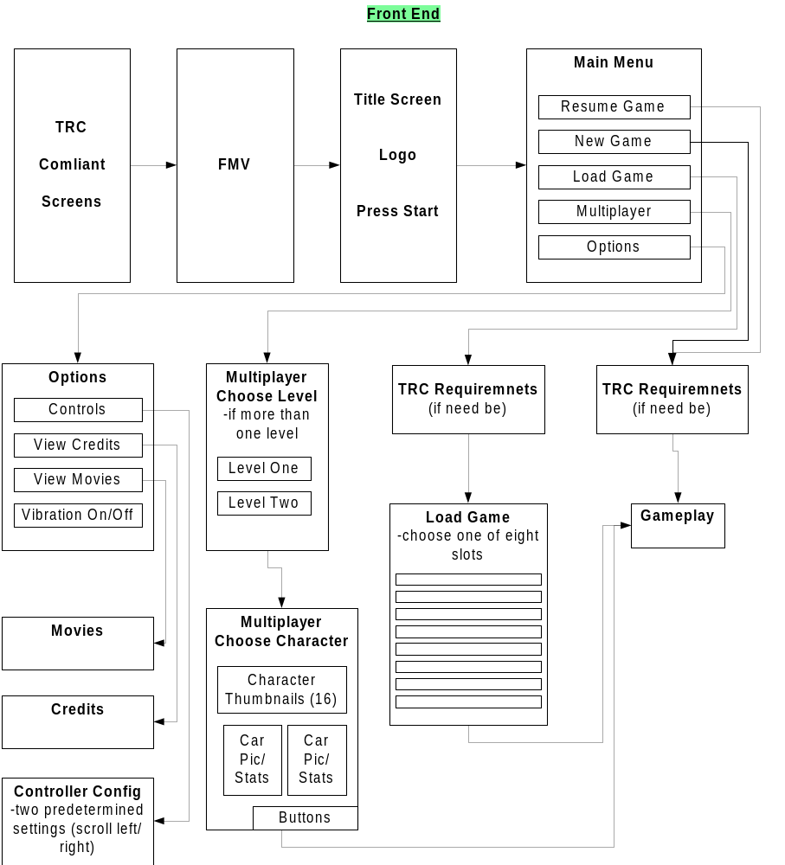

Continue Latest Game
Takes you straight to game play where you last saved your most recent game.

New Game
Takes you straight to game play starting at the beginning of the game. The User will have to save from the pause menu.

Load Game
The Memory card/Hard Drive will be divided into 8 Slots allowing for 8 possible different games to be saved. Games will be saved according to the following naming convention:
- Date
- Time
- Level
- Mission
Once a selection is chosen, the user will be taken directly to game play where they last saved the game they just loaded.

If a User wished to select a specific mission that they passed in a particular game, they would have to load that game, enter the gameplay, press START and select Mission Selection from the PAUSE menu.

Multiplayer
Try to get the players to the game as quick as possible. From the main Front end screen, the Users will be taken to the Select Vehicle screen (Unless we have more than one Multiplayer Level in which case they will be taken to the select level screen then to the choose vehicle). The choose vehicle screen will have a multiplayer interface (more than one player may pick a vehicle at one). Players (2-4) will have to activate their controllers by pressing any button or by simply moving the control pad/stick. The following information will be displayed:
- Character thumbnails (with a visual cursor for selection – color coded for players 1-4)
- Car Statistics
  - Speed (Hoarse power)
  - Turning ability
  - Weight (Durability)
- Car Picture (static)

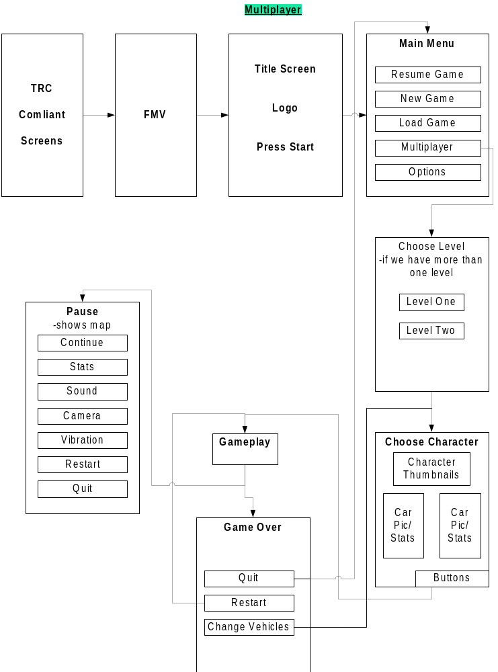

Options Menu

This menu should consist of plain art and simple, clear text. The functions are

- Controls Configuration – allow to customize controller configuration (separate screen)
- View Movies (separate screen)
- Game Credits (separate screen)
- AutoSave (on/off)

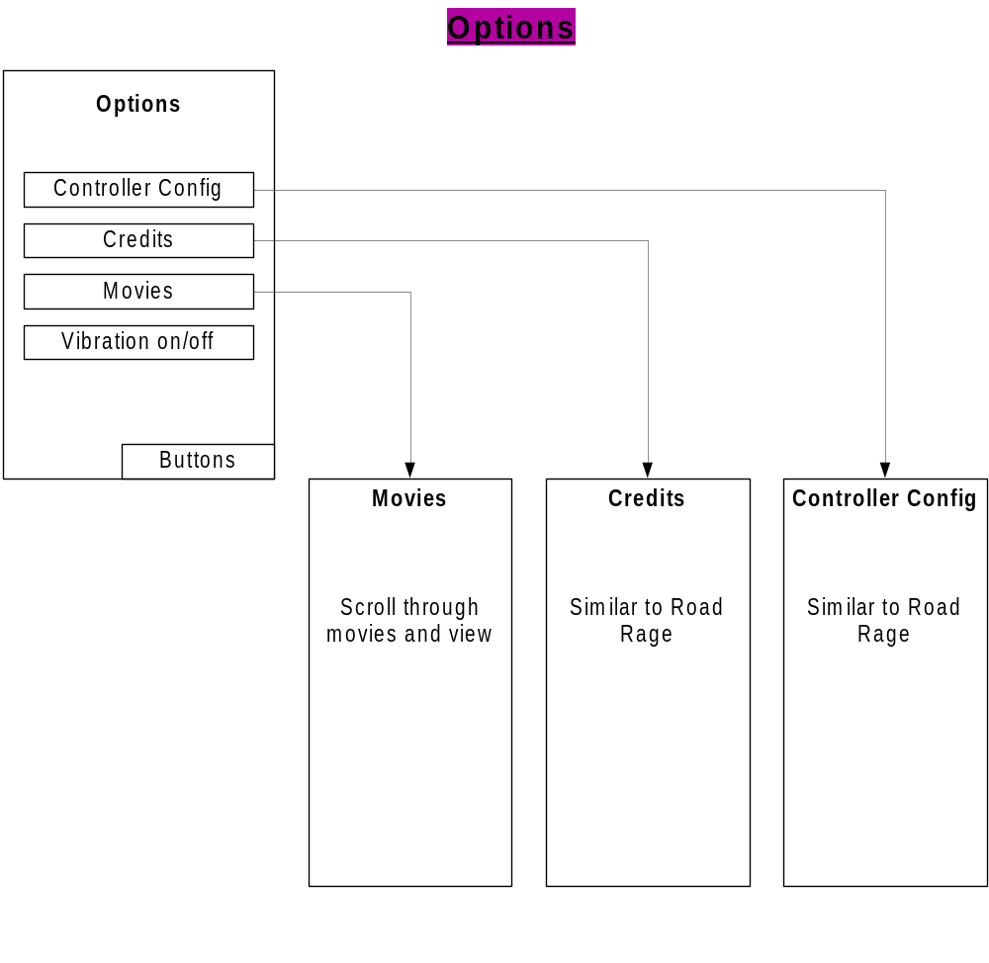

Pause Menu (Single Player)

The pause menu will be kept clean. By default, an enlarged version of the HUD map will be displayed (oriented in terms of the user direction, like the HUD map itself).
  - You don’t have to select it – the menu has a “working space” that displays the map. In other words, pressing pause automatically displays this map.
  - Convenient orientation for the User.
    - Located right on the pause screen
- Continue – Resume game
- Mission Info – lead you to a different screen containing all mission information including: objectives, tasks, progress, etc
- Save – lead you to a different screen allowing the user to save the game to the memory card and/or hard disk.
  - TRC concerns
  - Save menu contains eight slots for User games
    - Default to latest or loaded game
    - Games are identified by Date, Level, Mission (Not User defined)
- Select Mission - allows you to choose any completed character/mission – will likely cause a game/world load.
  - If you go back to an earlier mission, we need to “clear out” memory of which save file the current user is using, so that it does not get over-written unless the user explicitly says so
  - Shows eight icons representing the walking character at the beginning of the missions for each level (e.g., Bart’s head for the Bart level)
- Options
  - User Statistics – a set of statistics showing used progress through the game. For example, things like:
▪ % Game Complete
▪ Collectibles (bonus objects found)
▪ Miles/KMs driven
▪ Time played (how much time the user has played the game for)
▪ Police cars evaded
▪ Police cars disabled
▪ Times disabled by Police
o AutoSave on/off – allow the user to determine if they wish to auto-save after each successful mission completion
o Vibration on/off
  - Sound Settings – same as Road Rage
  - Camera Choice – same as Road Rage, but possibly without “Far” camera
- Quit Current Mission – restart from Sunday Drive mode
- Restart Current Mission – restart from beginning of mission
- Exit – return to main Front End

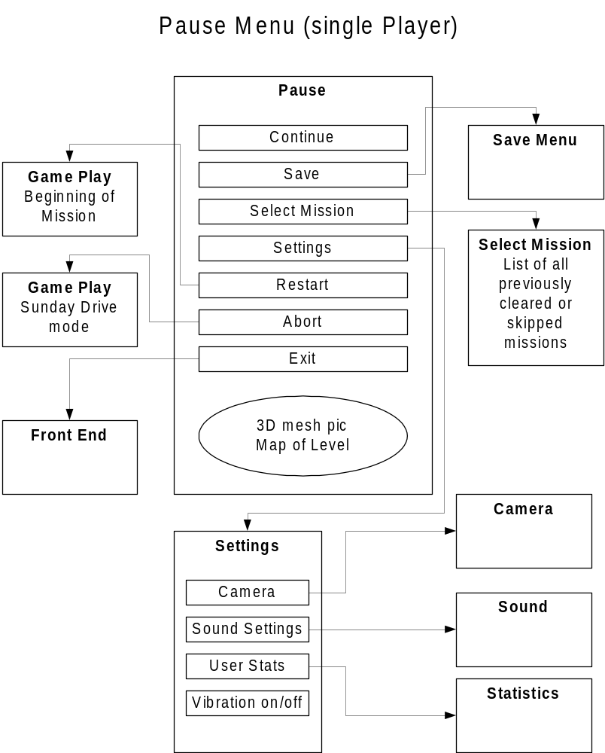

Pause Menu (Multiplayer)
The Multiplayer pause menu will be kept clean. By default, an enlarged version of the HUD map will be displayed (oriented in terms of the user direction, like the HUD map itself). Also, the User who paused will be indicated at the top of the pause menu (i.e. Paused – Player X)
  - You don’t have to select the map – the menu has a “working space” that displays the it. In other words, pressing pause automatically displays this map.
  - Convenient orientation for the User.
    - Located right on the pause screen
- Continue – resume game
- Options
  - User Statistics – a set of statistics showing used progress through the game. For example, things like:
▪ Score per player
▪ Steels
▪ Pickups
▪ Damage
o Vibration on/off
  - Sound Settings – same as Road Rage
  - Camera Choice – same as Road Rage, but possibly without “Far” camera
- Restart Head to Head – restart from beginning of mission
- Exit – return to main Front End

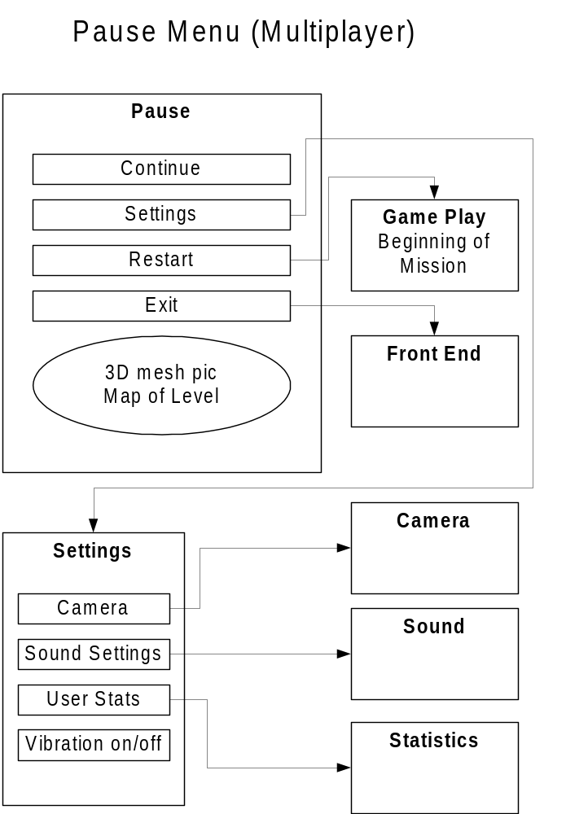

Memory Card (TRC Requirements)

Upon boot up, the first screen will be a license screen. From there the system will check to see if there is a memory card:
- If so
  - Check if formatted
    - If so
      - Check to see if available space
        - If so
          - Check to see if a game file exists
            - If so
              - Go to company screens then to main menu
            - If not
              - Ask if they would like to initialize a file for save (give amount of space necessary)
                - If so, initialize and if successful proceed
                - If not, ask if they would like to continue without save
        - If not
          - Warn user that there is not enough space to save a game (give amount of space necessary)
        - If card is damaged
          - Warn user that the card is damage
        - If data on the card is corrupt
          - Warn user that the card has corrupted data (ask to format)
    - If not
      - Ask to format and loop
- If not
  - Warn the user that there is no memory card and that they will not be able to save if they choose to continue

Menus

Generic
1. Generic Yes/No
2. Generic General Message (x=ok)

Memory Card
3. No memory card. Proceed?
4. Memory card not formatted
5. Memory card Damaged
6. Memory card contains corrupt data
7. Not enough memory
8. Game requires nKB. Initialize?
9. File successfully initialized

10. Main Menu

Multiplayer
11. Multiplayer Choose Level
12. Multiplayer Choose Character

13. Load Game
14. Game successfully Loaded

Options
15. Options
16. Controller configuration
17. View Movies
18. Game Credits

Pause Menu (single player)
19. Pause Menu (single player)
20. Mission Info
21. Save Screen
22. Game successfully saved
23. Select Mission
24. Options
25. User Statistics – a set of statistics showing used progress through the game. For example, things like:
26. AutoSave on/off – allow the user to determine if they wish to auto-save after each successful mission completion
27. Vibration on/off
28. Sound Settings – same as Road Rage
29. Camera Choice
30. Quit
31. Restart
32. Exit

Pause Menu (multiplayer player)
33. Pause Menu (multiplayer player)
34. Options
35. User Statistics – a set of statistics showing used progress through the game. For example, things like:
36. AutoSave on/off – allow the user to determine if they wish to auto-save after each successful mission completion
37. Vibration on/off
38. Sound Settings – same as Road Rage
39. Camera Choice
40. Restart
41. Exit

42. Game Over (multiplayer)

Tools

- Use text bible approach from day one

Content

- All screens will be in 2D
- Music
- Ambient sound effects
- The simplest possible pause and options art, with a text font that the program uses to put text onto the screen. For example, this menu screen from Smuggler’s Run 2 is exactly as simple (artistically) as we want ours to be:

Head Up Display (HUD)

Goals

- Simple, effective, animated presentation of the information the user needs

Features

- The information the user needs on the HUD is:
  - Map for navigation, including location of collectibles and AI opponents
  - Counter-measure availability and use indicator
  - Damage meter
  - Speedometer (question: digital or analog?)
  - Indication of collectible requirement/status for multiple collectibles, e.g., if you have to deliver or destroy N objects
  - Mission objective (text? Or just character dialog?)
- The map, damage meter, and counter measures can all be shown in one simple HUD object as in Smuggler’s Run 2:
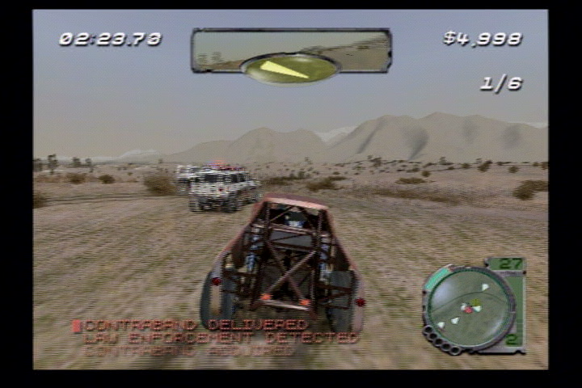
    - Simple animation (flashing) on counter-measure light when it’s used (or recharged)
- The collectible status will glow or pulsate, with a sound effect, when it is updated
- A timer – this is one of the most prominent HUD elements, since time will be a factor in most missions.
  - Simplest solution is a simple digital counter
  - Needs animation (e.g., blinking red) and sound, both of which increase in frequency, as it nears zero – same system and logic as Road Rage should work fine
  - If there’s a way to make it prominent enough, it can be part of the HUD map “object” – but it may be hard to read? Does it need to be separate “floating” text? Same issue applies to collectible status.

Tools

- The simpler the better. All we should need to tune is animation around collectible status update and the timer.

Player Navigation

Goals

- Simple and consistent - always works the same way from the user's POV
- Error free - never points in the wrong direction
- Flexible – allows for user choice of path when we want it to (e.g., missions with multiple pickups and user choice of the order)
- Low learning curve for the user

Features

- The HUD map displays one or more target icons. If it’s off-map, then it slides along the edge of the HUD map.
- NO arrow on the HUD as in Road Rage.
- Map icons are removed when the user picks up the item or completes the objective.
- The pause screen will show a large version of the map as the default pause function.
- The map will rotate to match the user’s orientation (on both the HUD and pause screen) as in Road Rage and Midtown Madness 2.
- Targets, including moving ones such as AI vehicles, will have a highlight arrow floating over them in space. The arrow is “3D” in that it gets larger the closer you get.
- Mission-specific navigation instructions, verbally issued from passenger to driver. For example, hit a particular collision volume and Bart, as the passenger, will say to Homer, “Turn left, Dude!”
- General world (not mission-specific) instructions from passenger to driver (e.g., “I think that’s a shortcut”)

Design Notes

- The first few missions in the game must be carefully designed to slowly teach the user how to navigate in the game world.

Tools

- Designers can lay down mission-specific collision volumes that are linked to navigation instructions, for example:
  - Turn left
  - Turn right
  - Go straight
  - Turn around
  - Go up the hill
  - Go down the hill
  - Take the jump
  - There’s a shortcut
- Designers can lay down similar information that’s always in a level, not mission-specific. This might be useful for pointing out shortcuts or other world features.
- Each walking character will have dialog for these instructions (might be able to reuse some Road Rage dialog).

Questions

- When the target is a moving AI vehicle, what happens when they are off-screen or behind you? Could the vehicle highlight be a beam of light for greater visibility?
  - Whatever the solution, remember that it will be used in multiplayer too.

